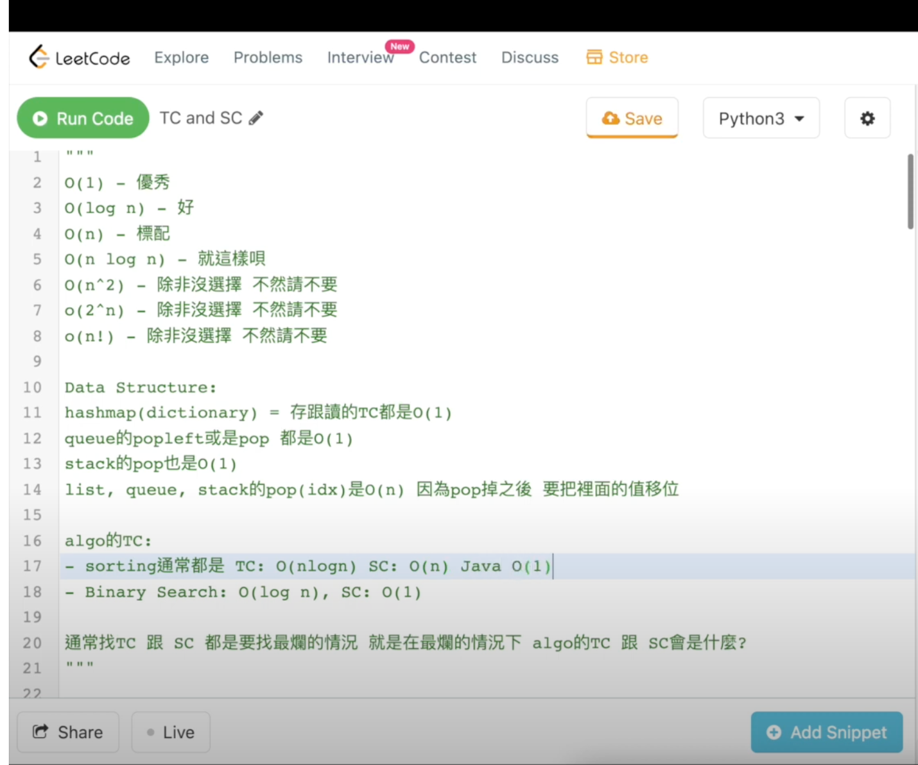

Tips:

1. One for loop -> TC: O(n), SC: O(1)

2. Nested for loops -> TC: O(n^2) or O(n*m), SC: O(1) cuz one structure

3. Hash map -> TC: O(1), SC: O(N)

4. Binary Search -> TC: O(log n), SC: O(1)

5. Linear Search -> TC: O(n), SC: O(1)

6. Arrays.sort() -> TC: O(nlogn), SC: O(1)

7. most built-in sorting functions(Bubble, Selection, Insertion) -> TC: O(nlogn), SC: O(1)

8. Merge Sort -> TC: O(nlogn), SC: O(n)

9. Quick Sort -> TC: O(nlogn), SC: O(log n) due to recursion

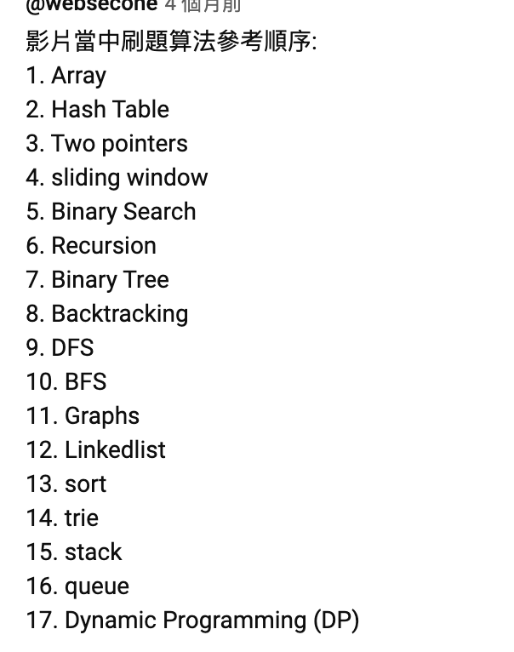

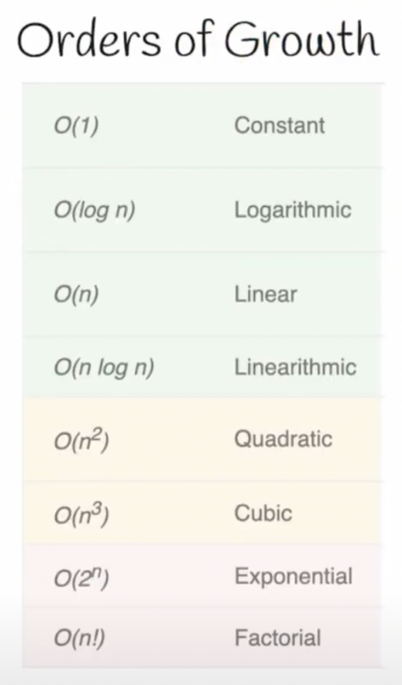

**217. Contains Duplicate**

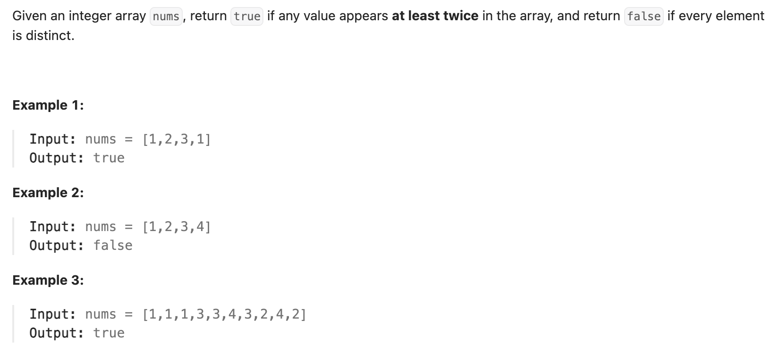

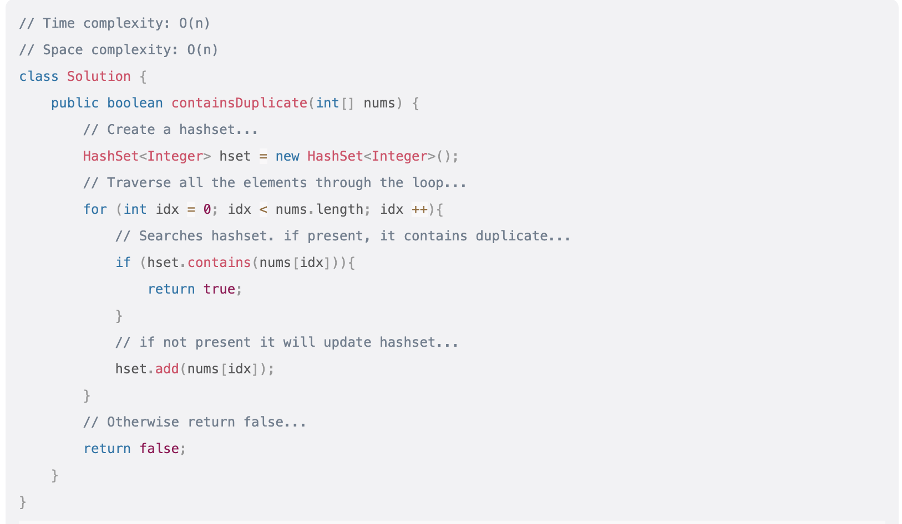

or

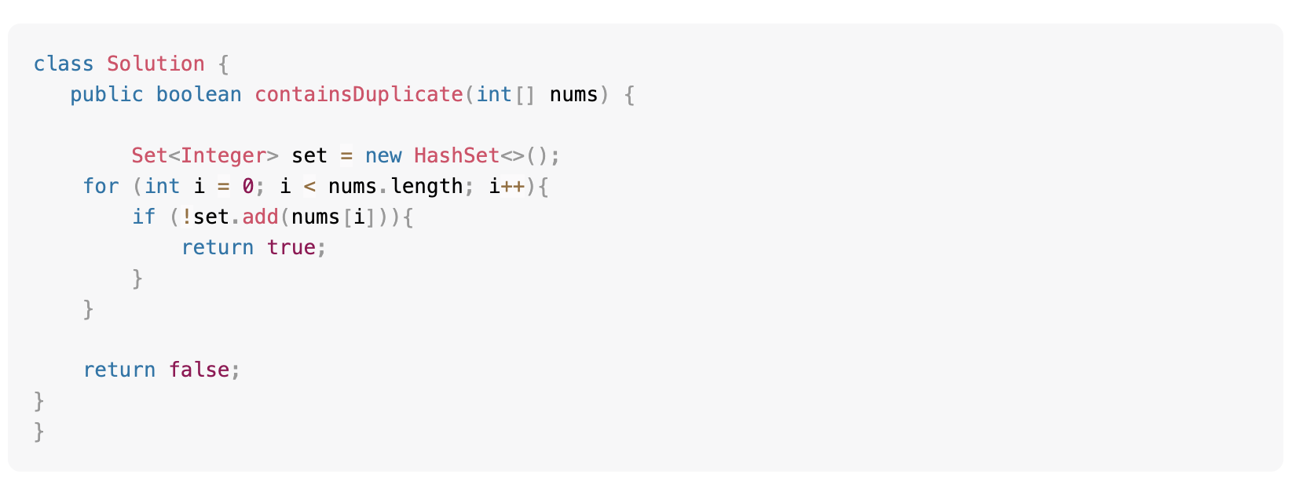

Set already checks if it contains the variable upon adding.

TC: O(n)

SC: O(n)

**242. Valid Anagram**

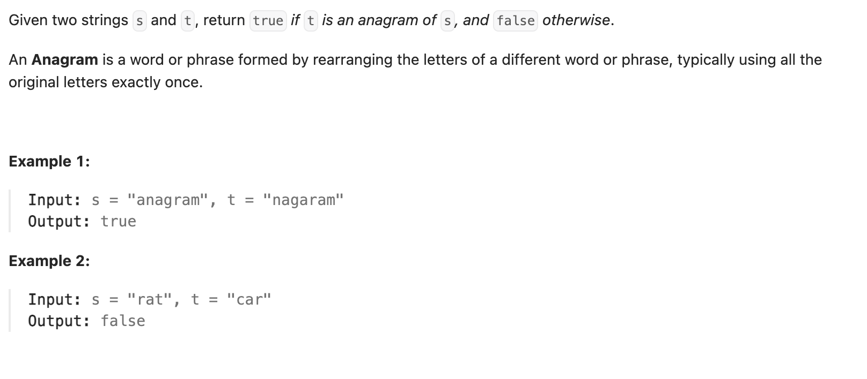

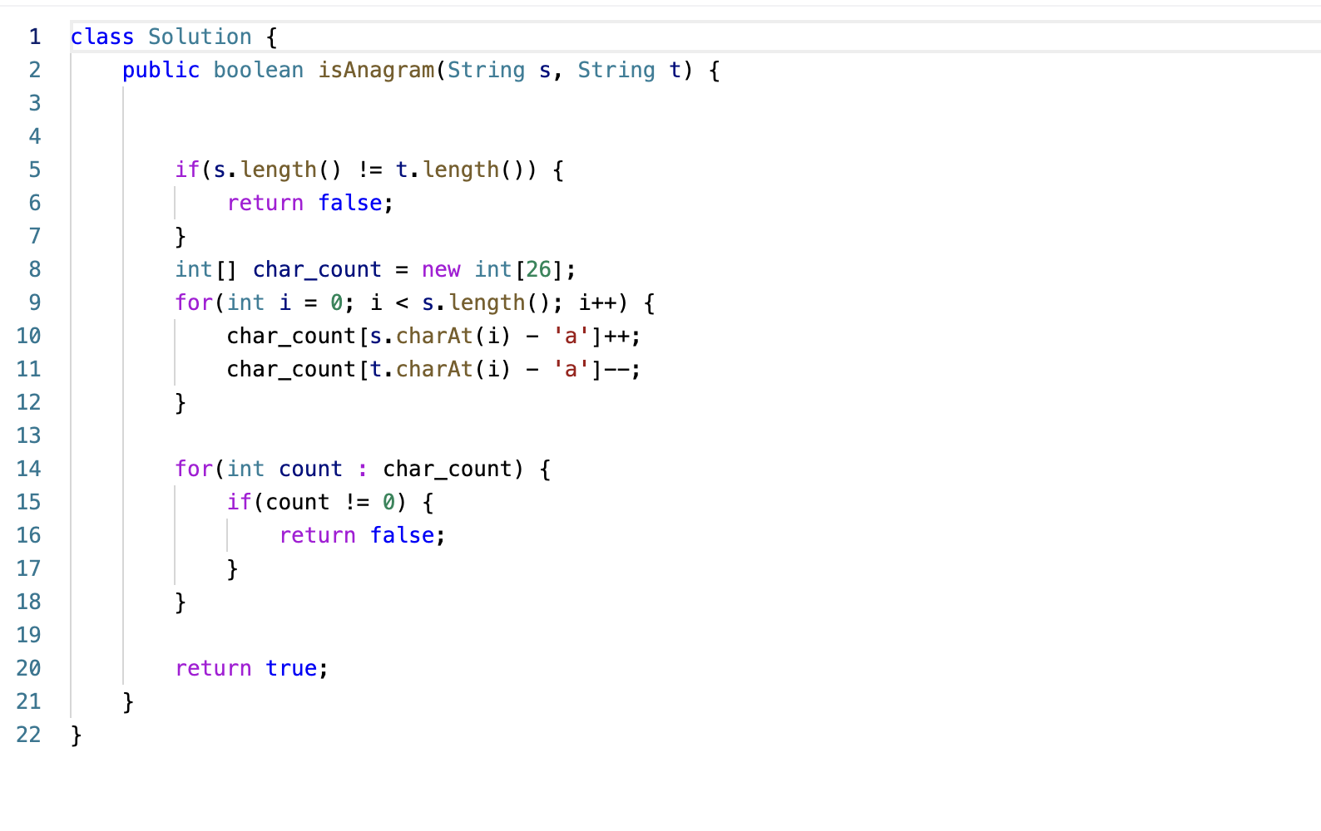

TC: O(n), where n is the length of the strings.

SC: O(1), because the size of the char_count array is fixed at 26, which is a constant value. Therefore, the space required to store the char_count array does not depend on the length of the strings.

**1. Two Sum**

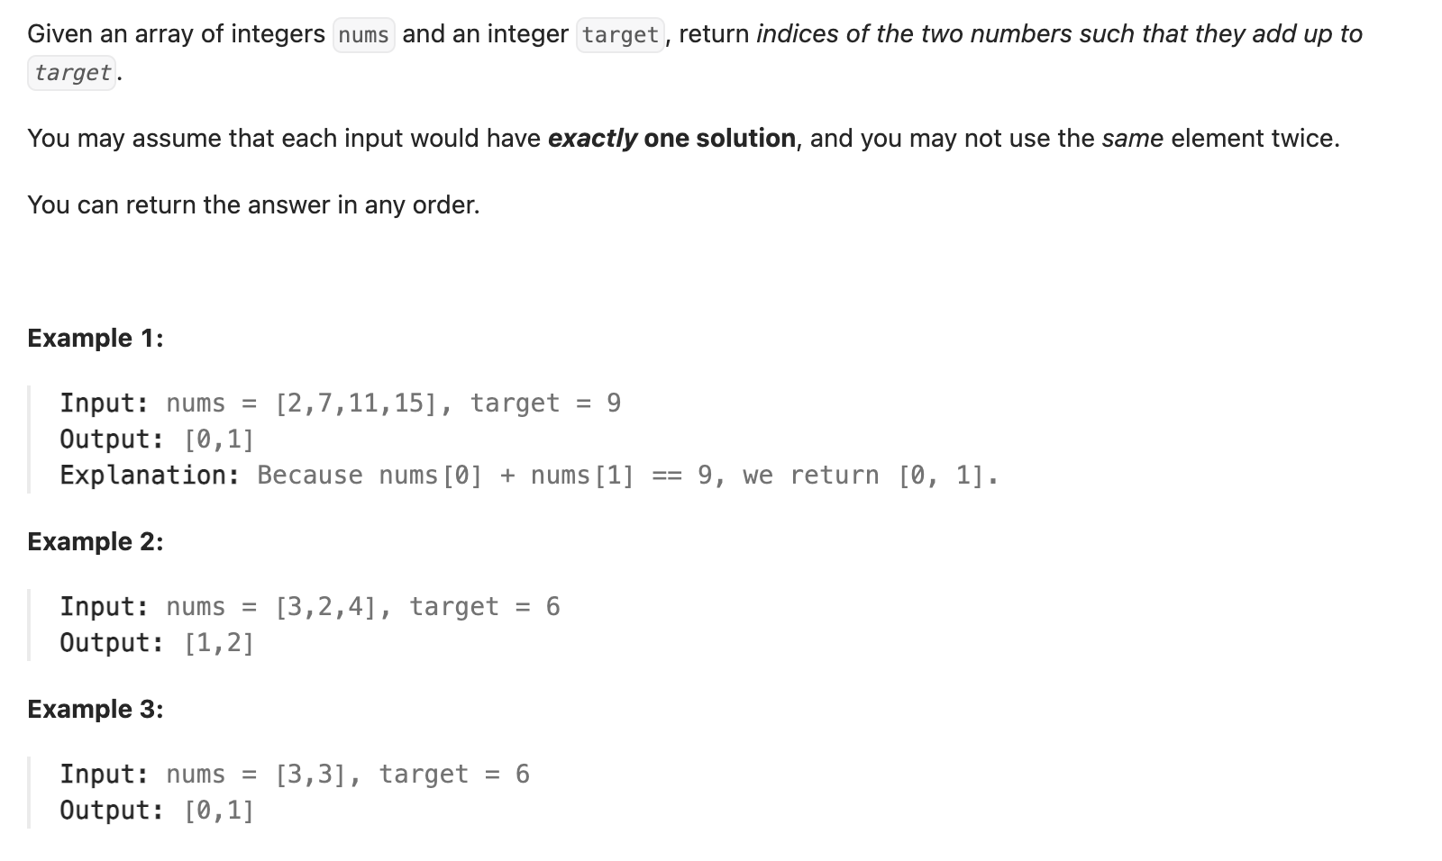

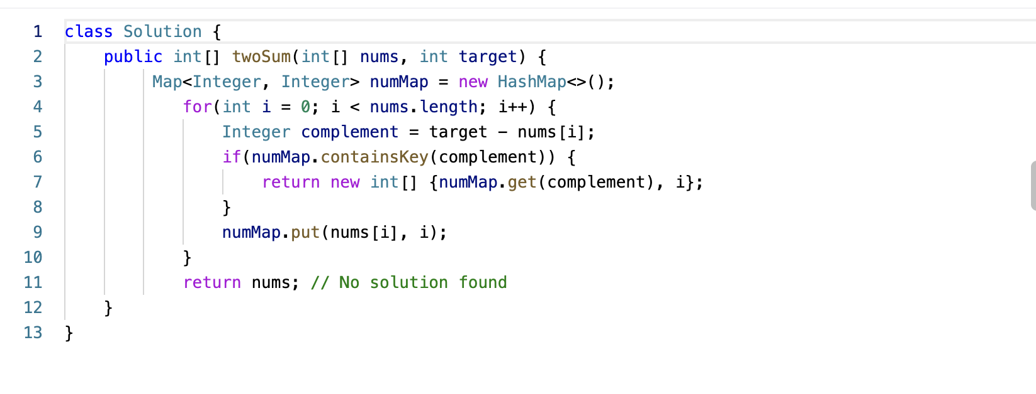

TC: O(n)

SC: O(n)

**49. Group Anagrams**

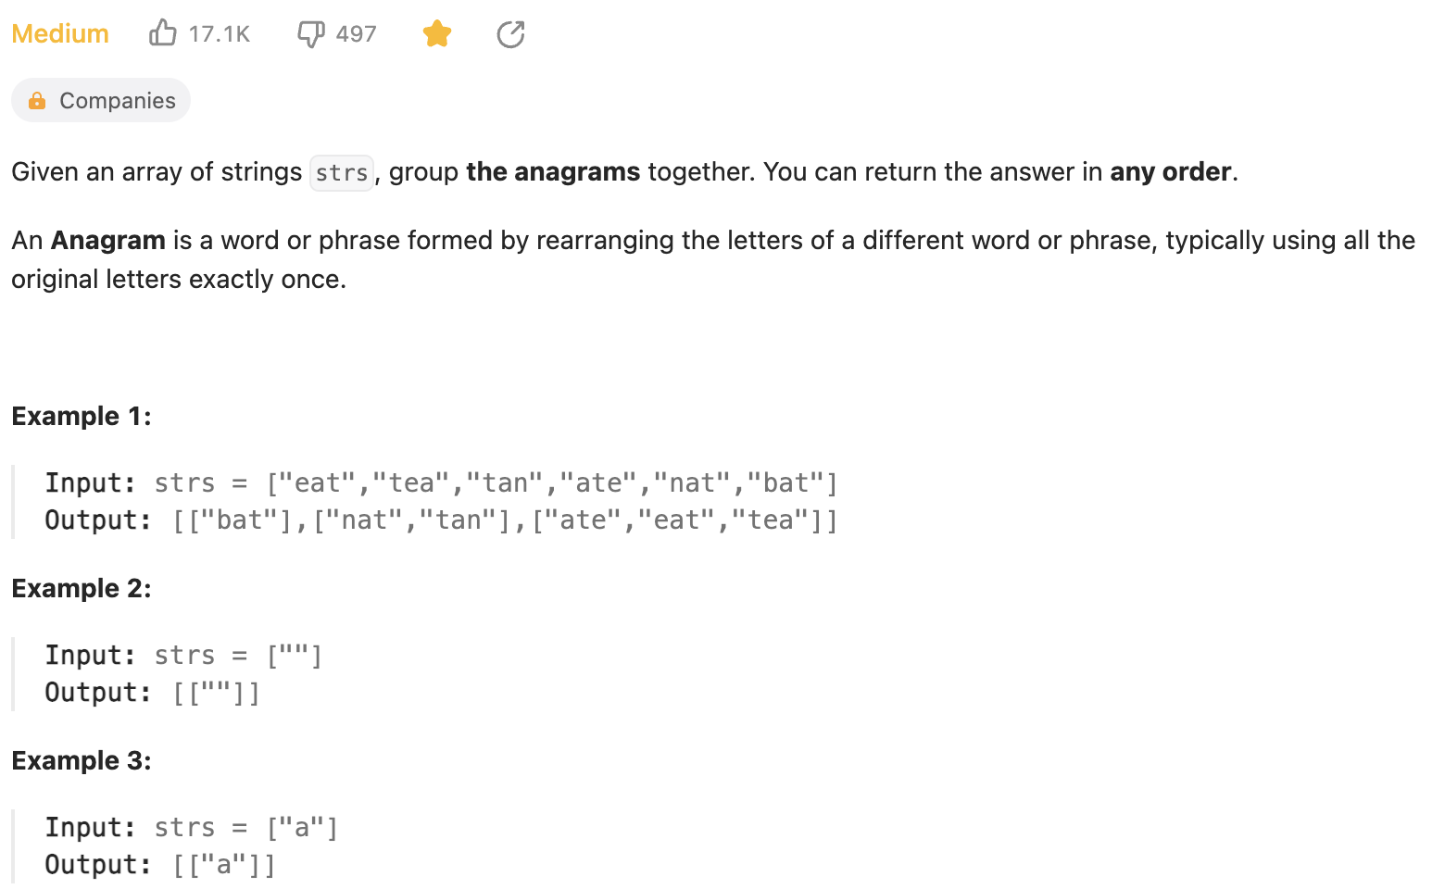

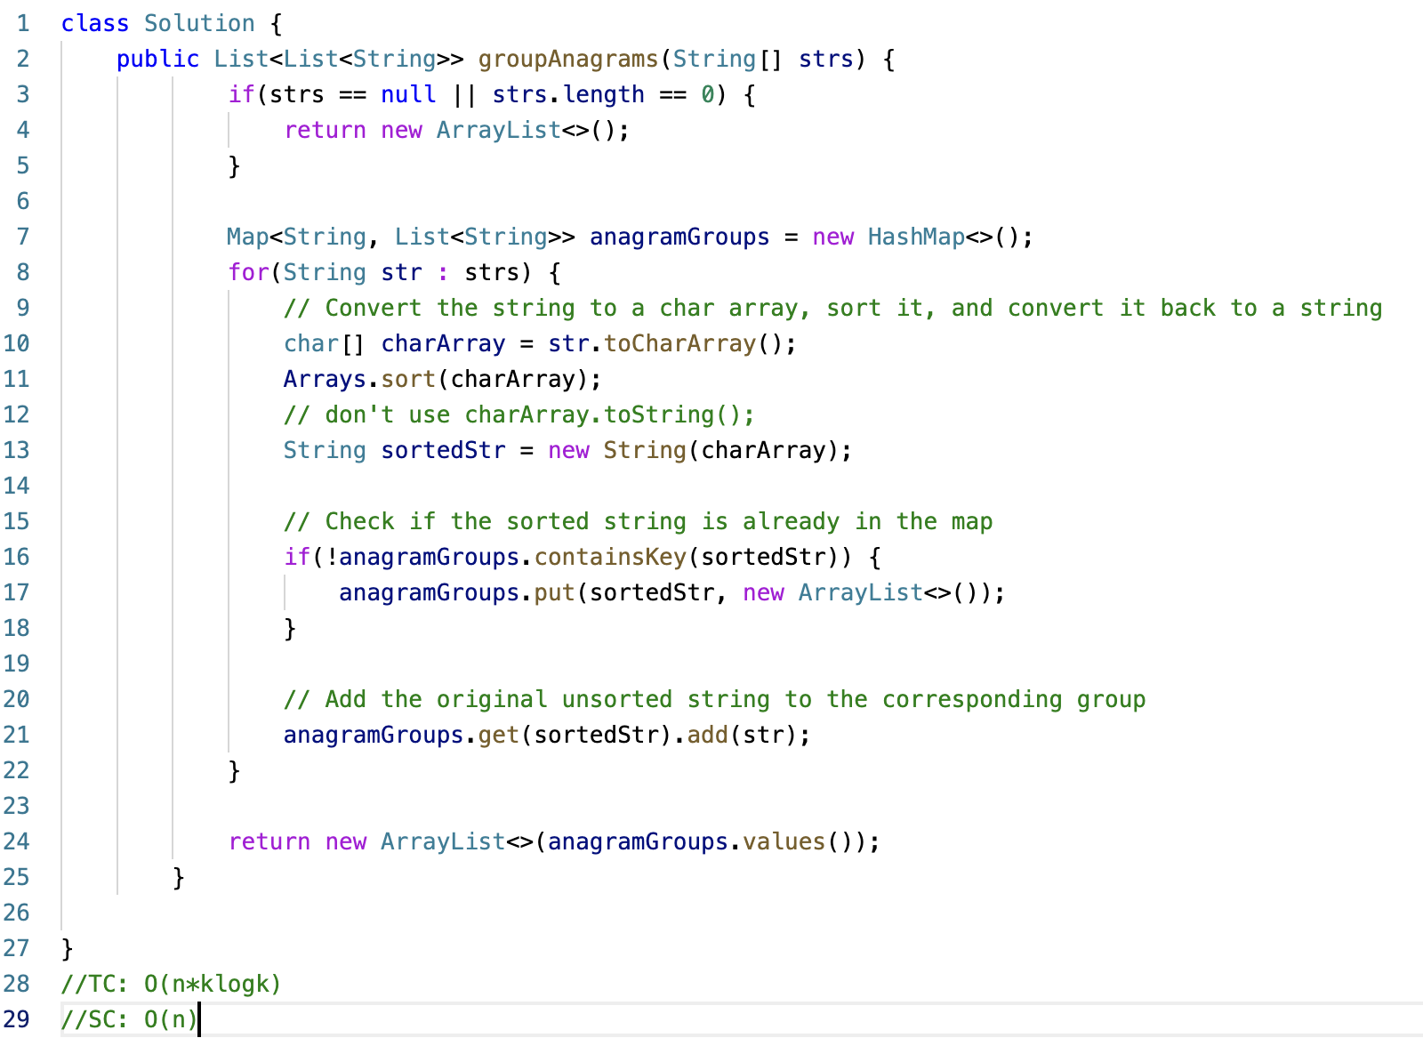

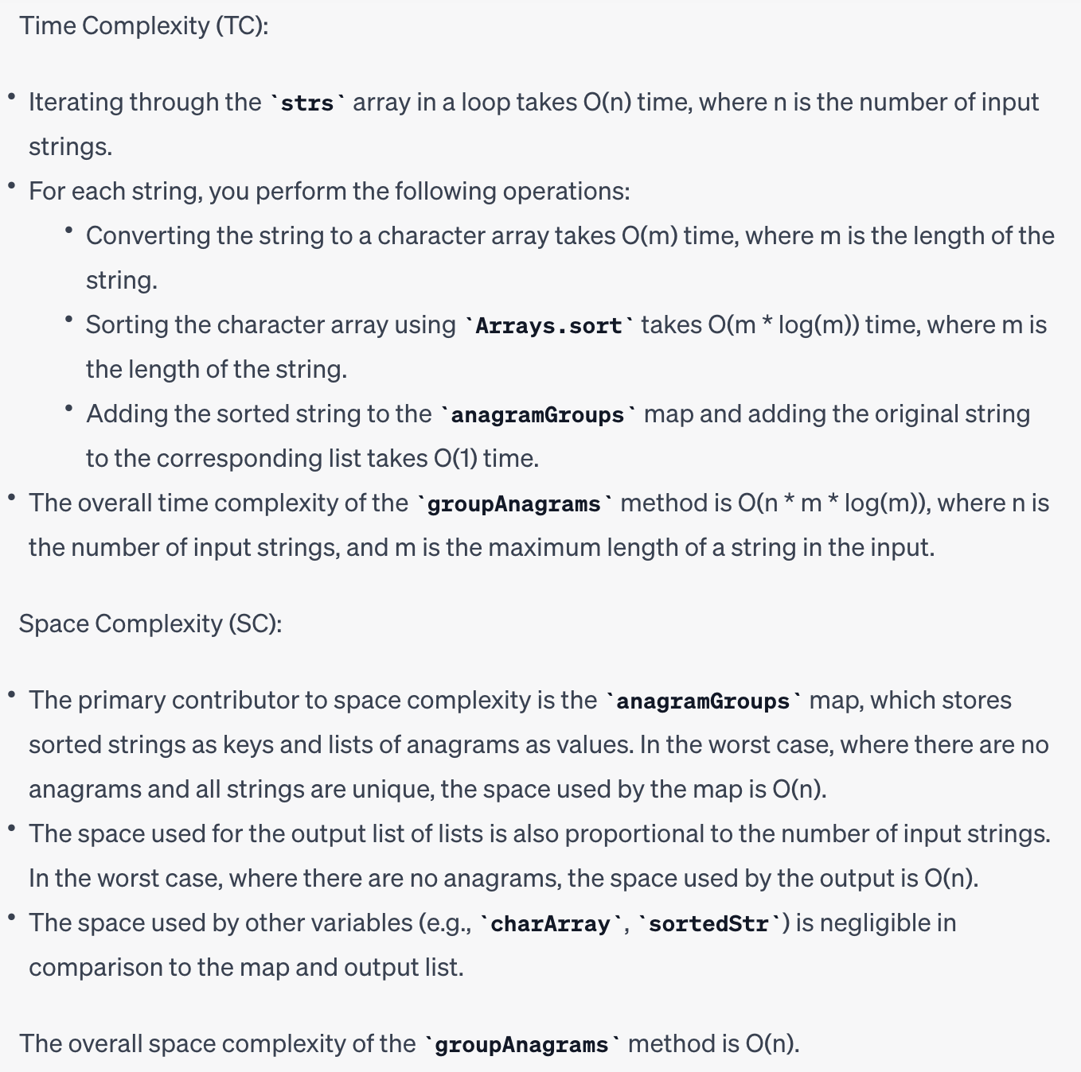

**347. Top K Frequent Elements**

<https://www.youtube.com/watch?v=EBNPu0GgM64>

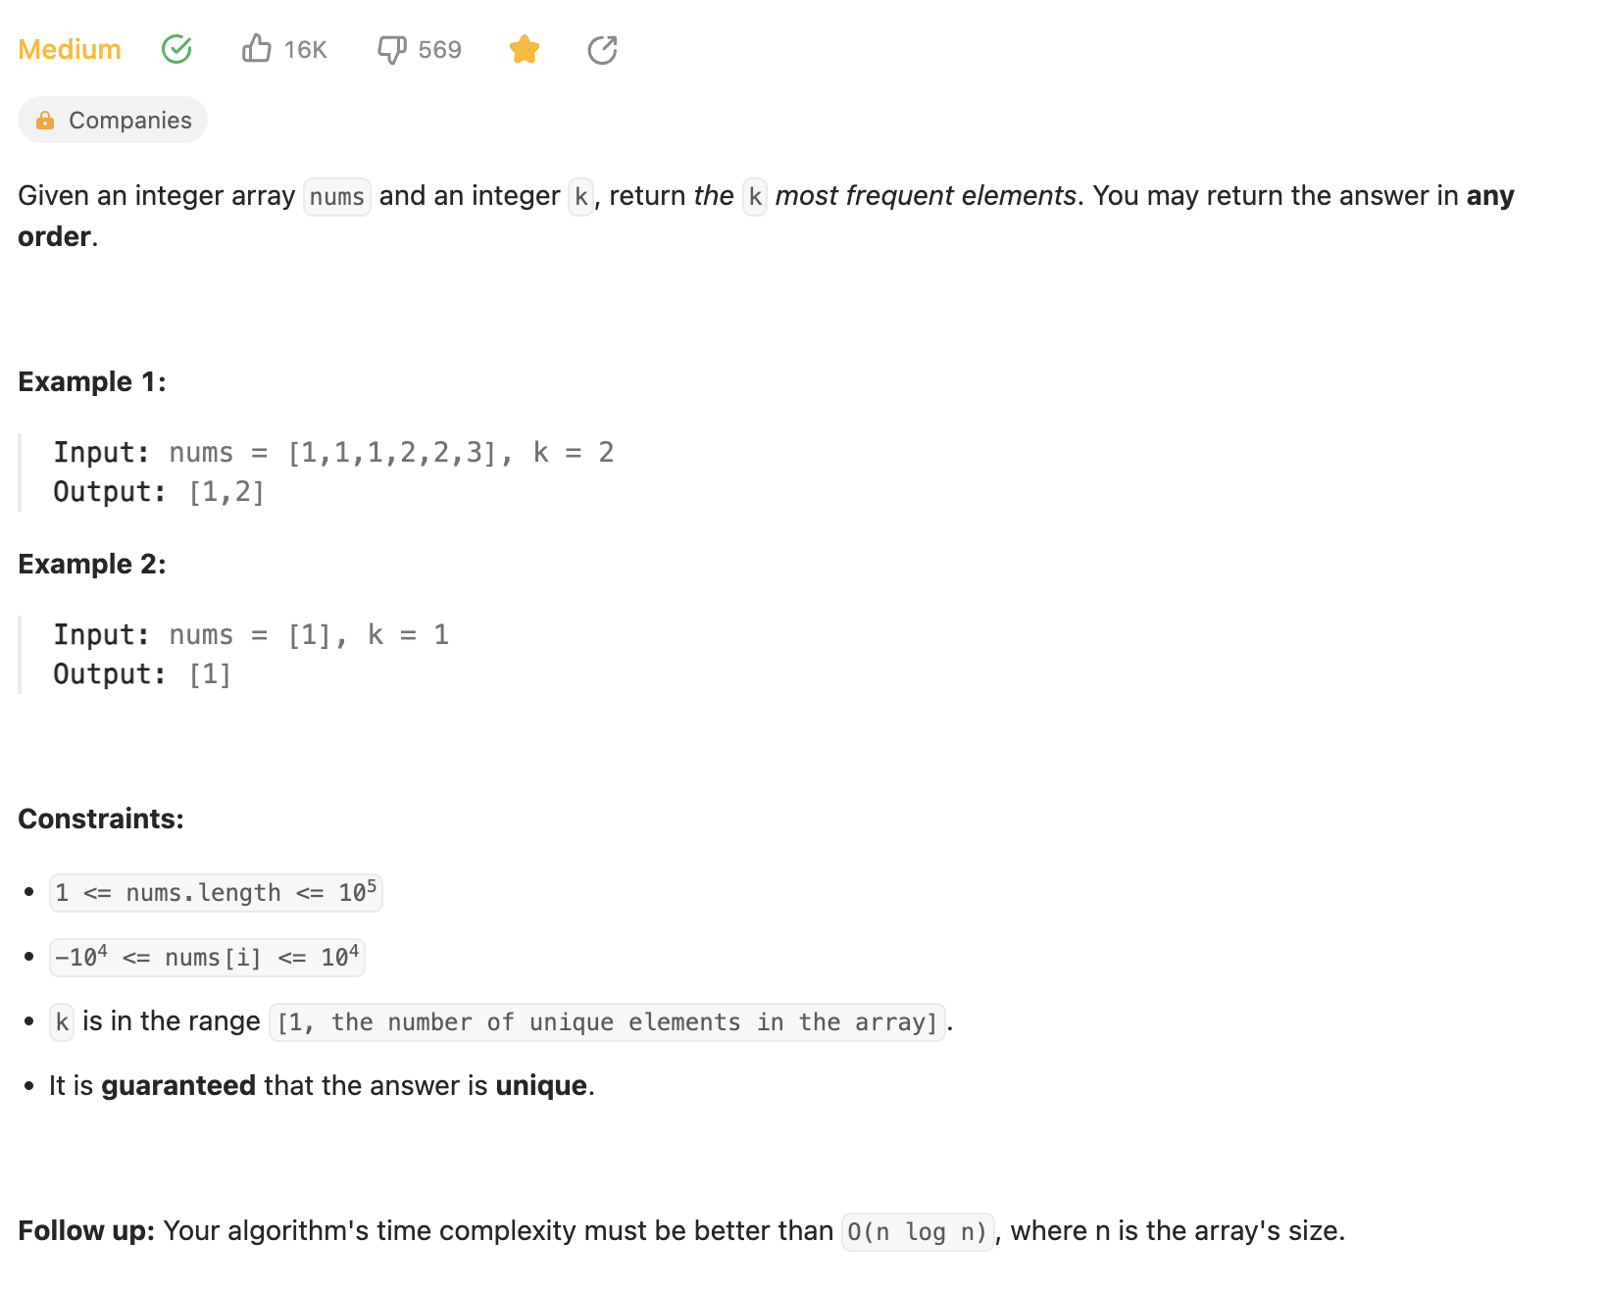

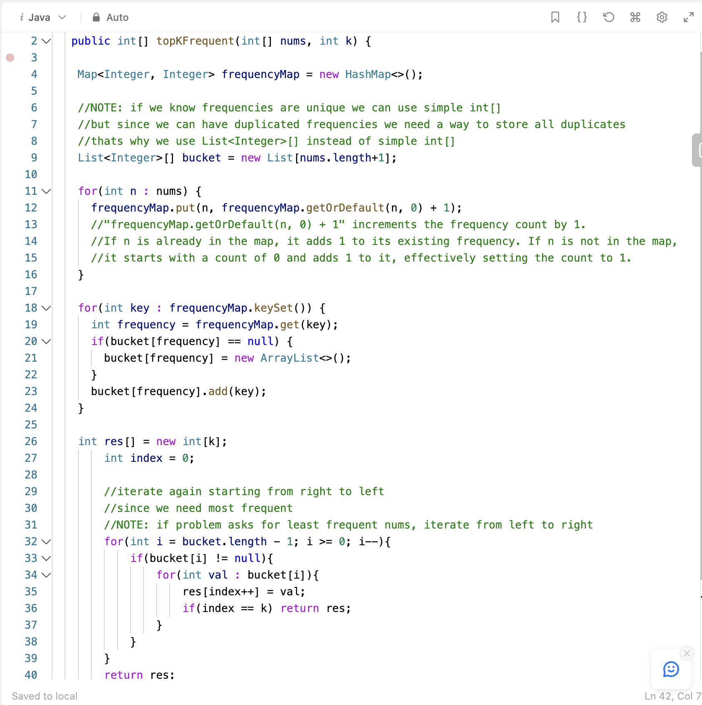

TC: O(n), The bucket iteration loop has a nested structure, with two levels of iteration:

The inner loop iterates over the elements within each bucket.

The key insight here is that the sum of the sizes of all buckets across all frequencies is equal to the total number of elements in the input array nums. In other words, every element from the nums array is placed into one of the buckets.

Therefore, when considering both levels of iteration together, the time complexity of the bucket iteration is still O(n), where n is the number of elements in the input array nums. This is because the total number of iterations across both levels of the loop is proportional to the total number of elements in nums.

SC: O(n)

**125. Valid Palindrome**

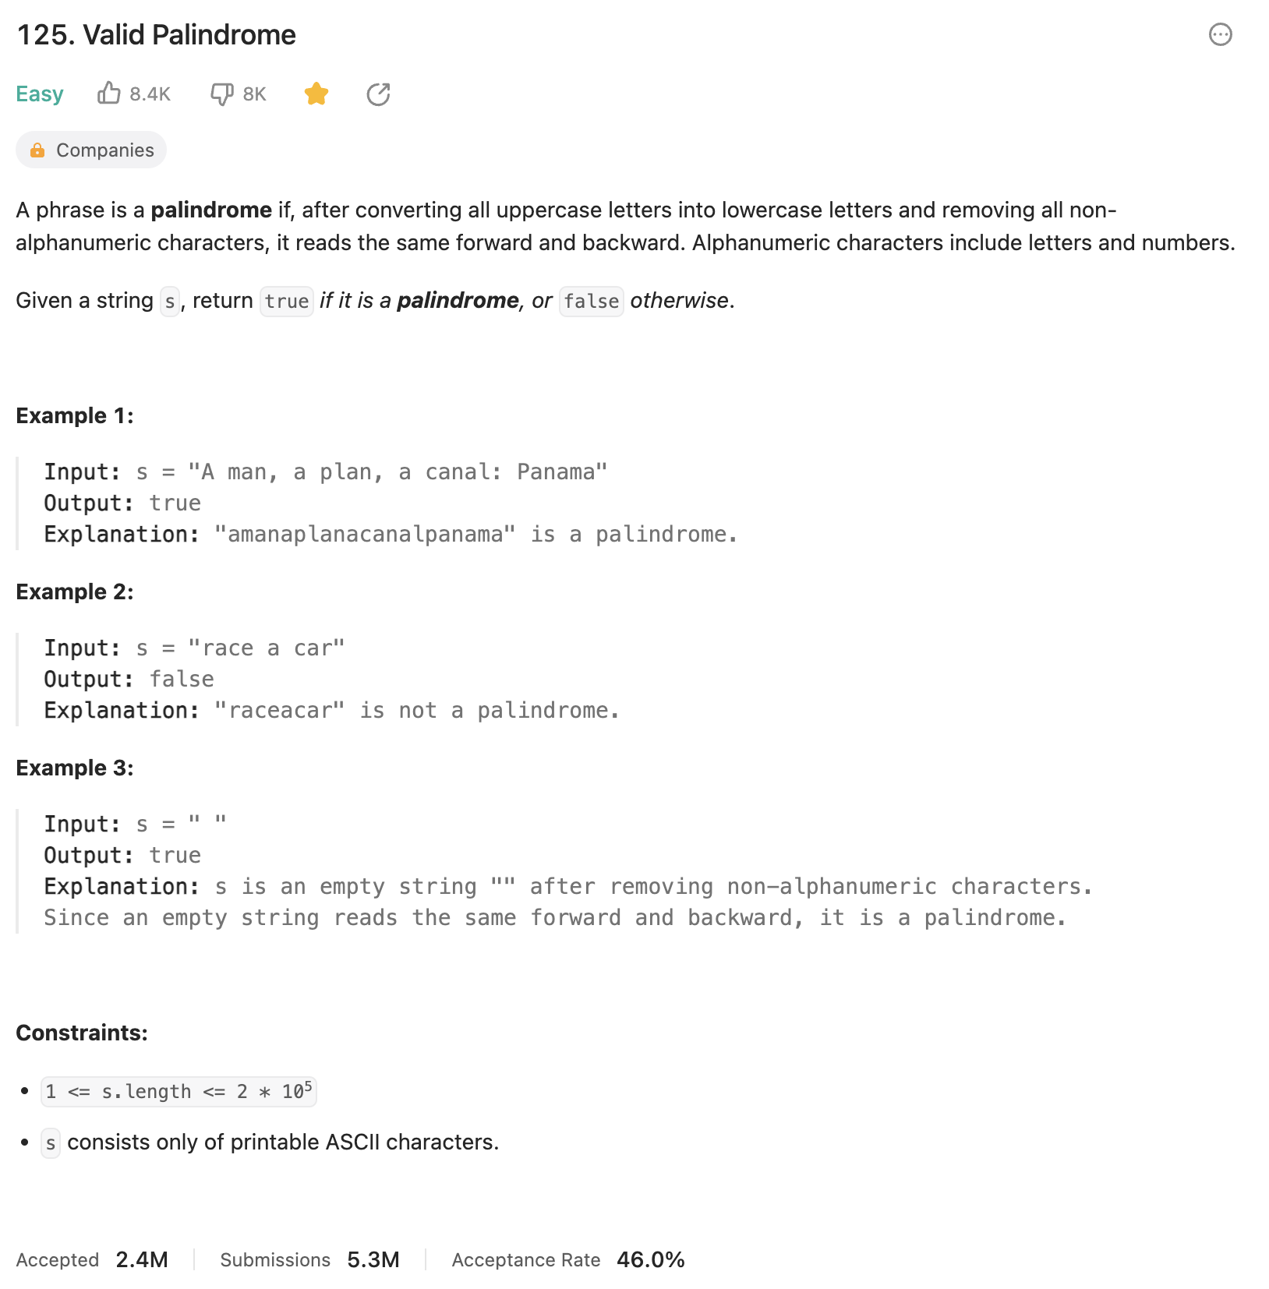

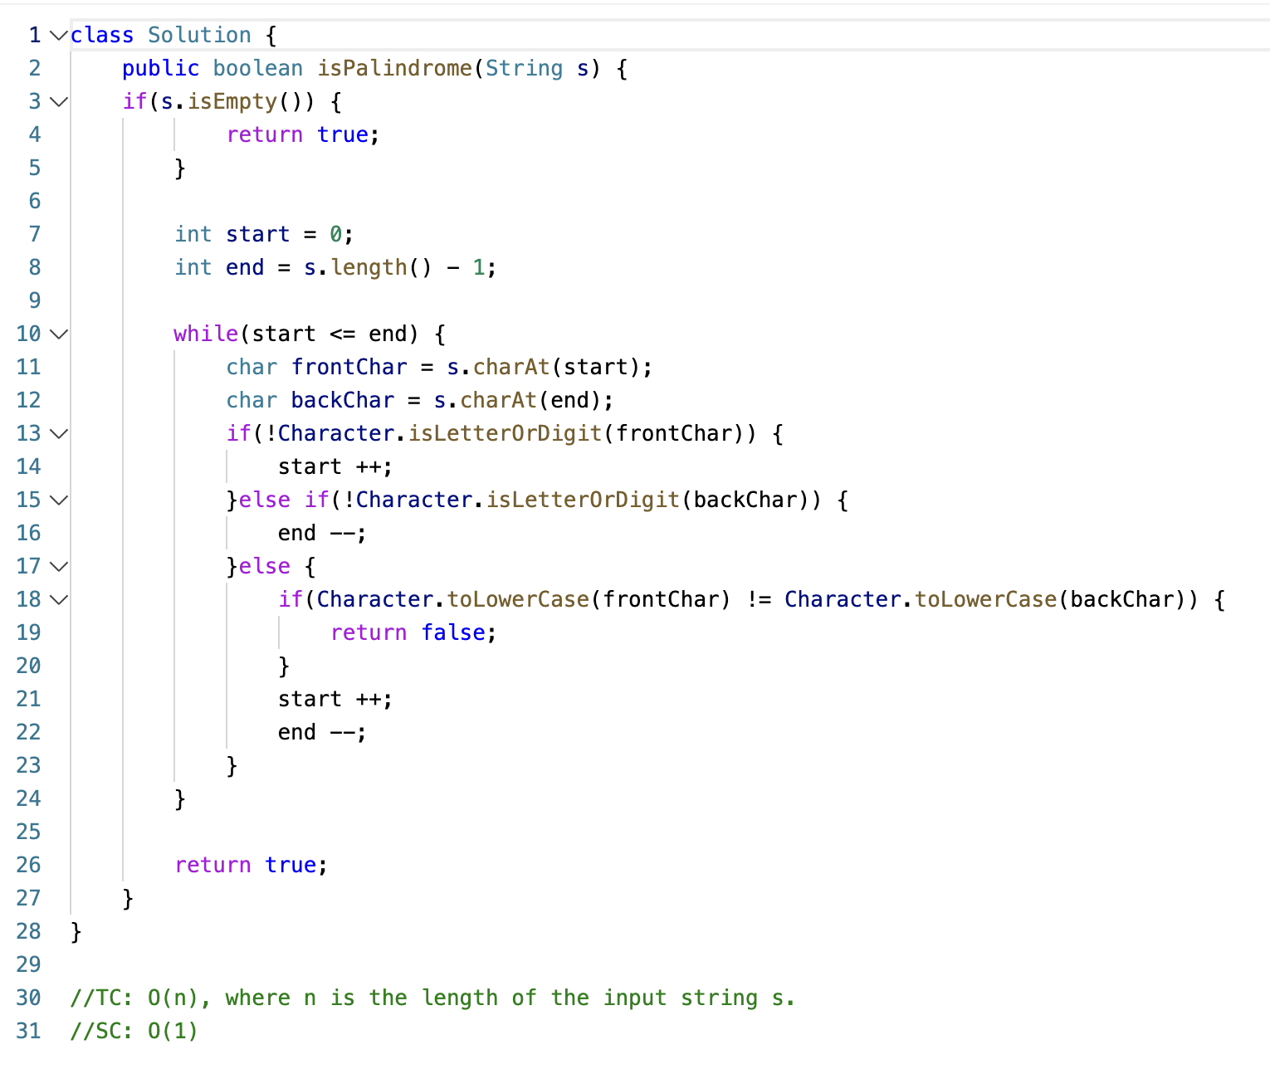

**167. Two Sum II - Input Array Is Sorted**

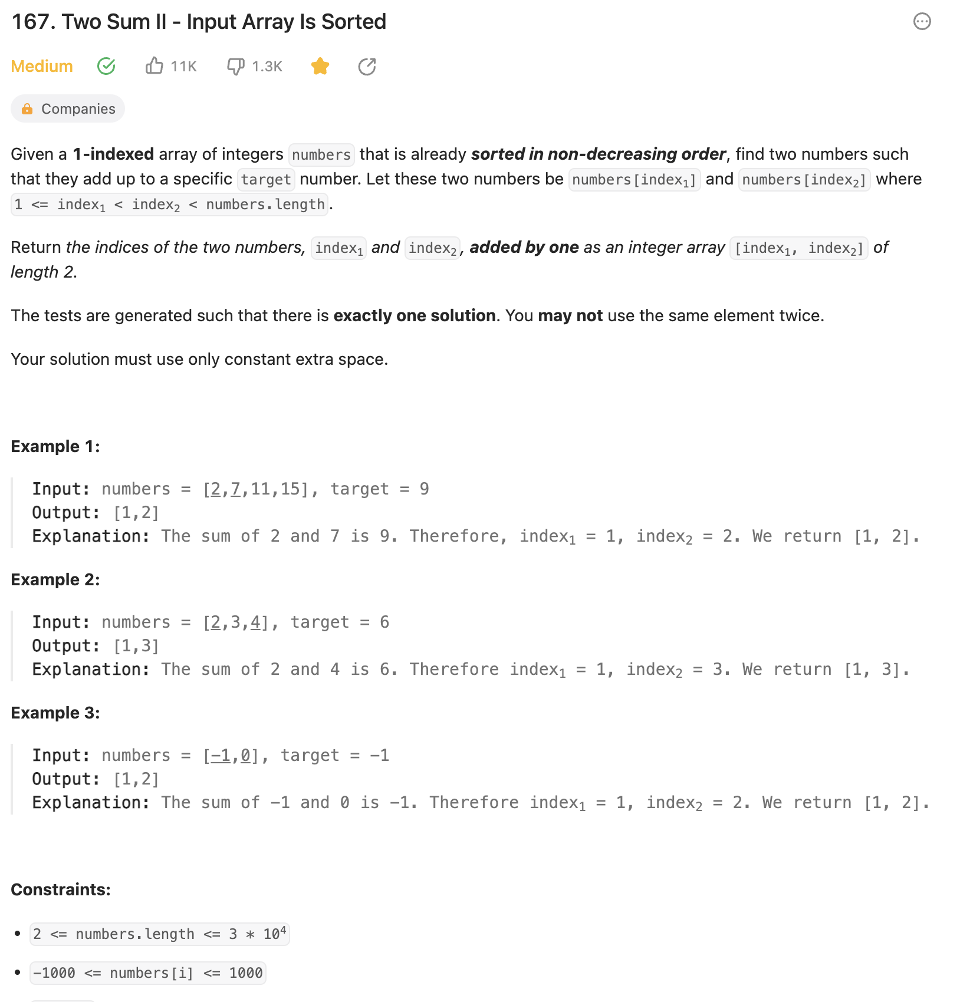

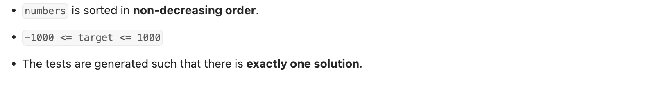

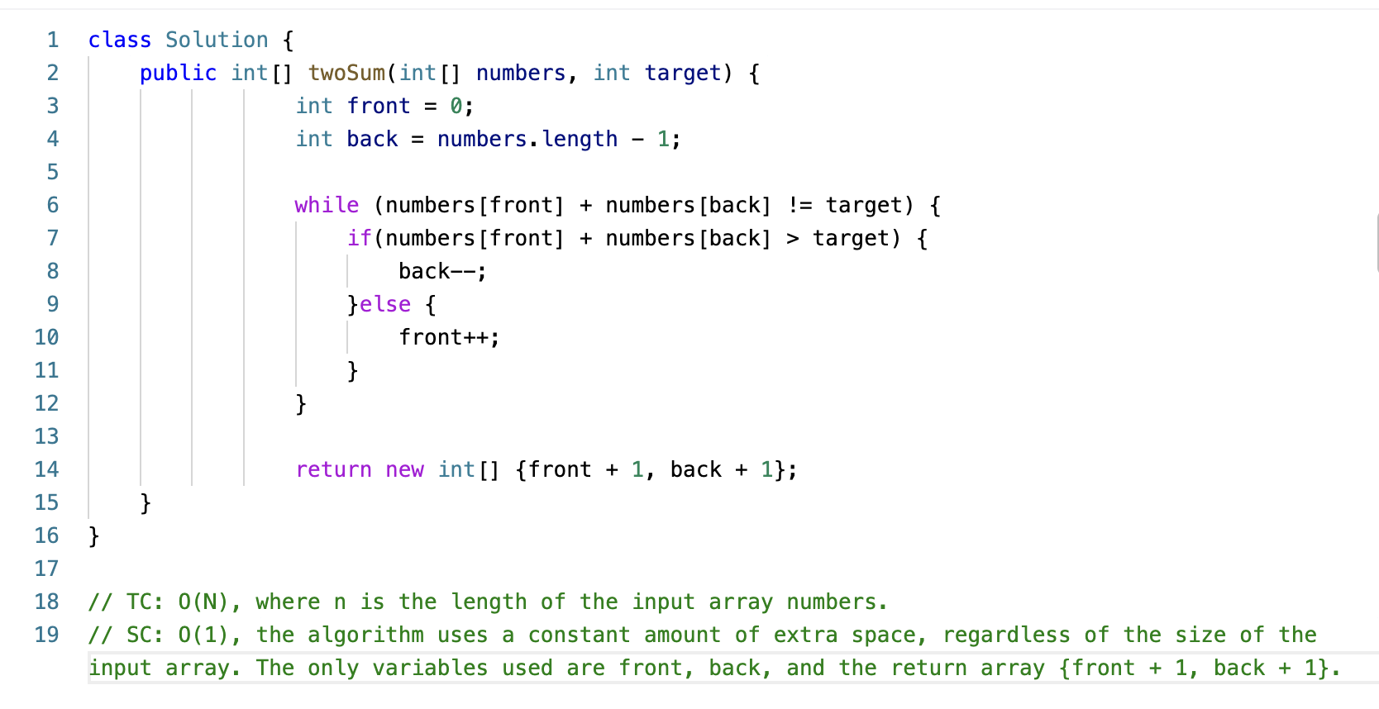

**121. Best Time to Buy and Sell Stock**

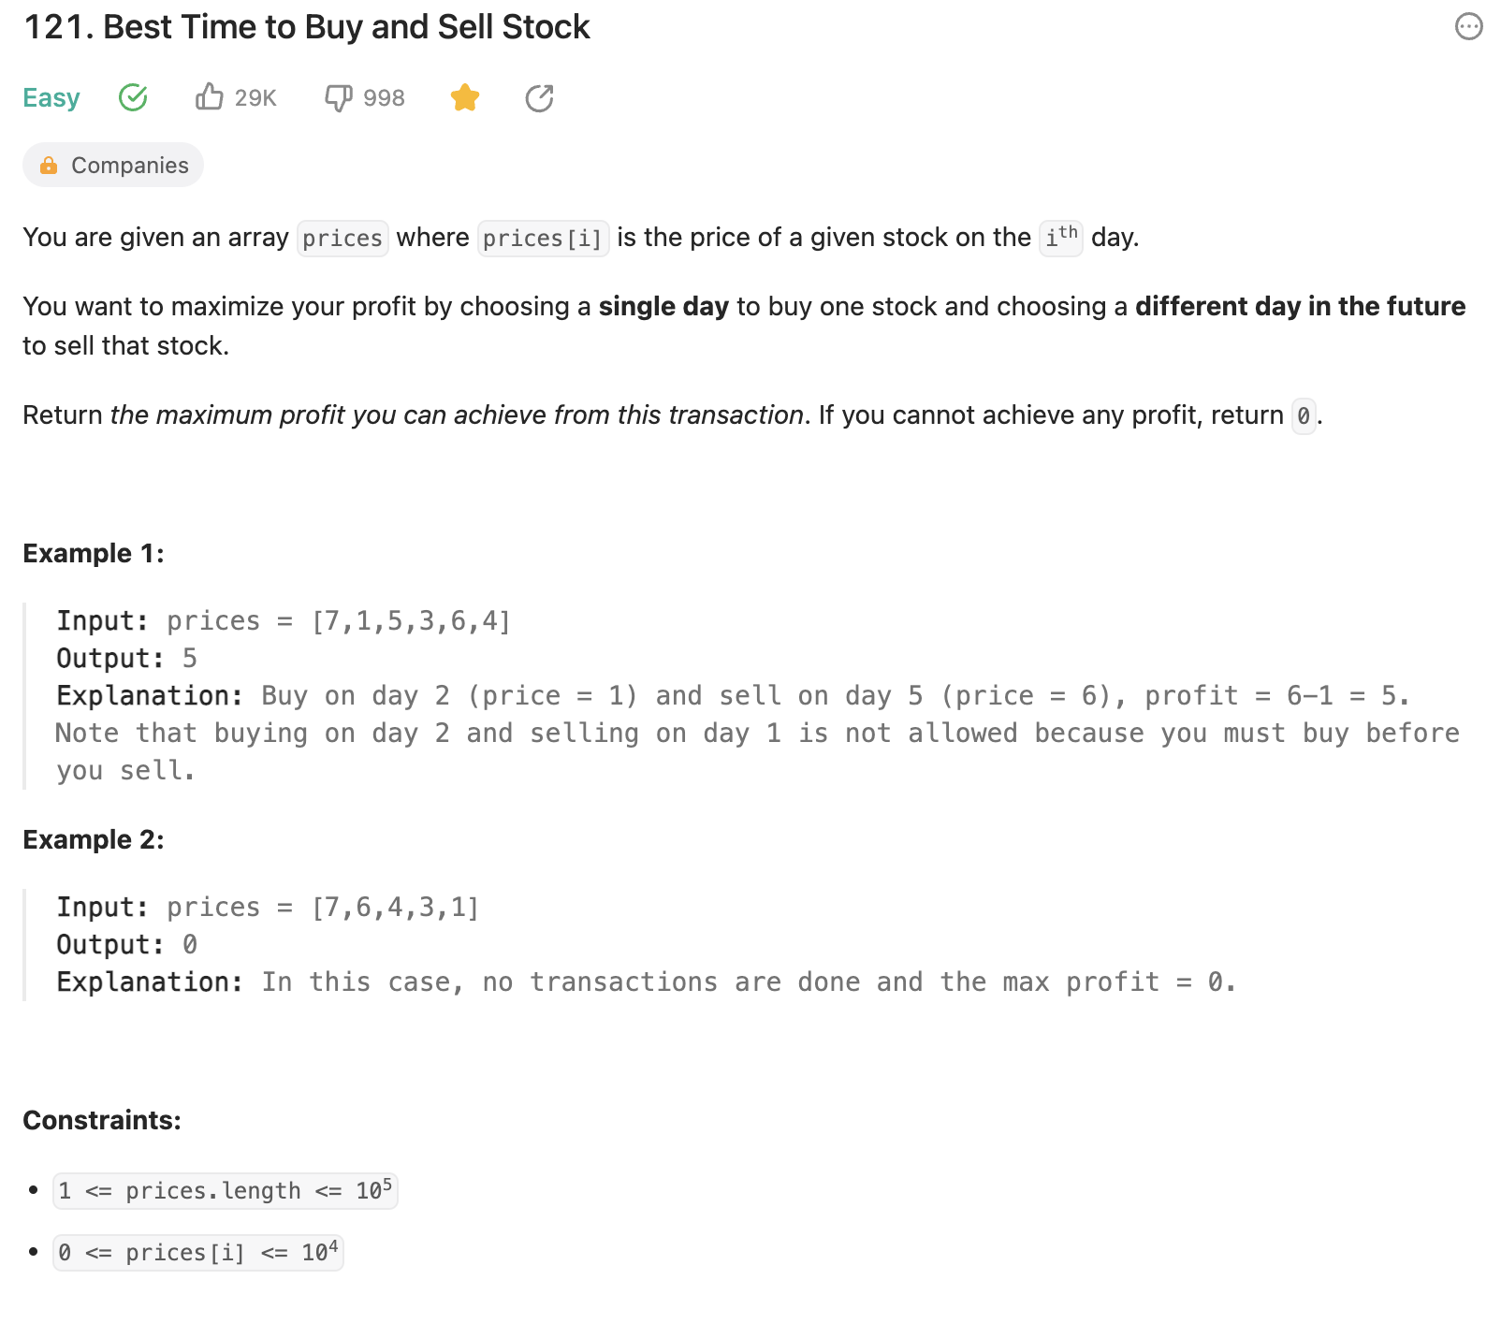

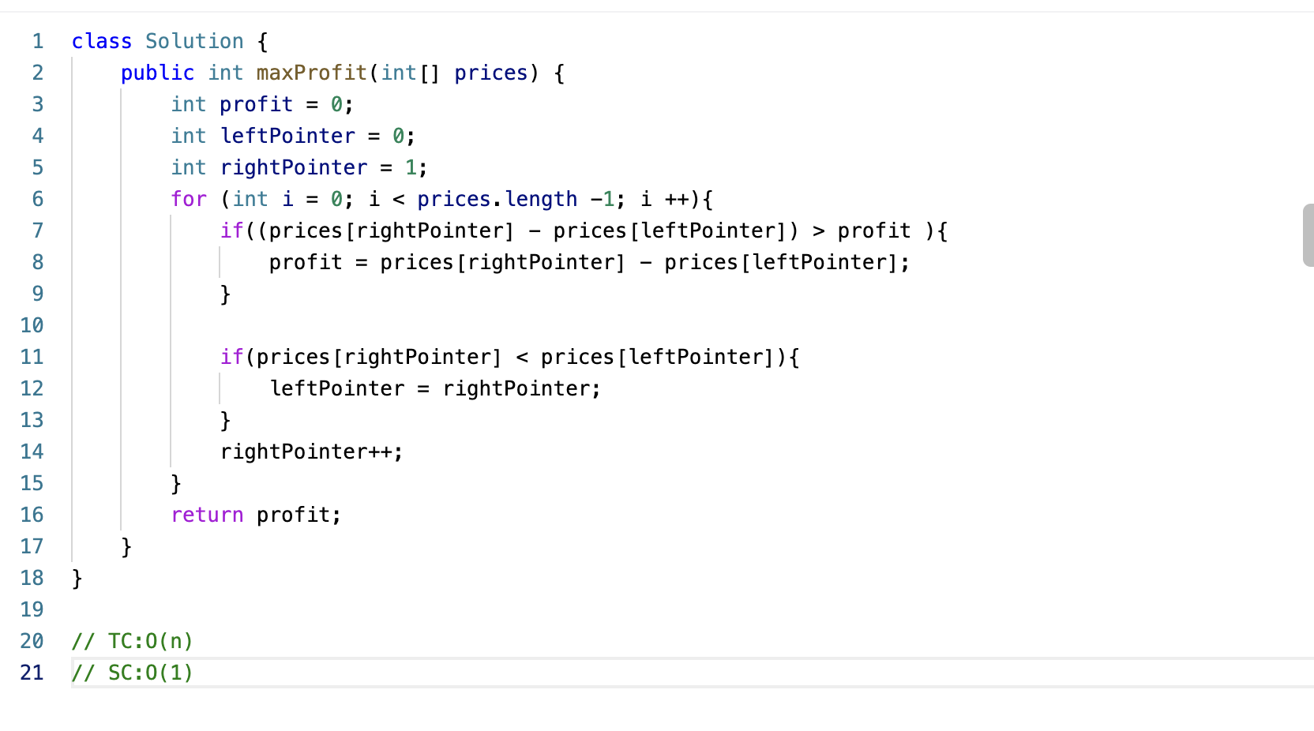

**3. Longest Substring Without Repeating Characters**

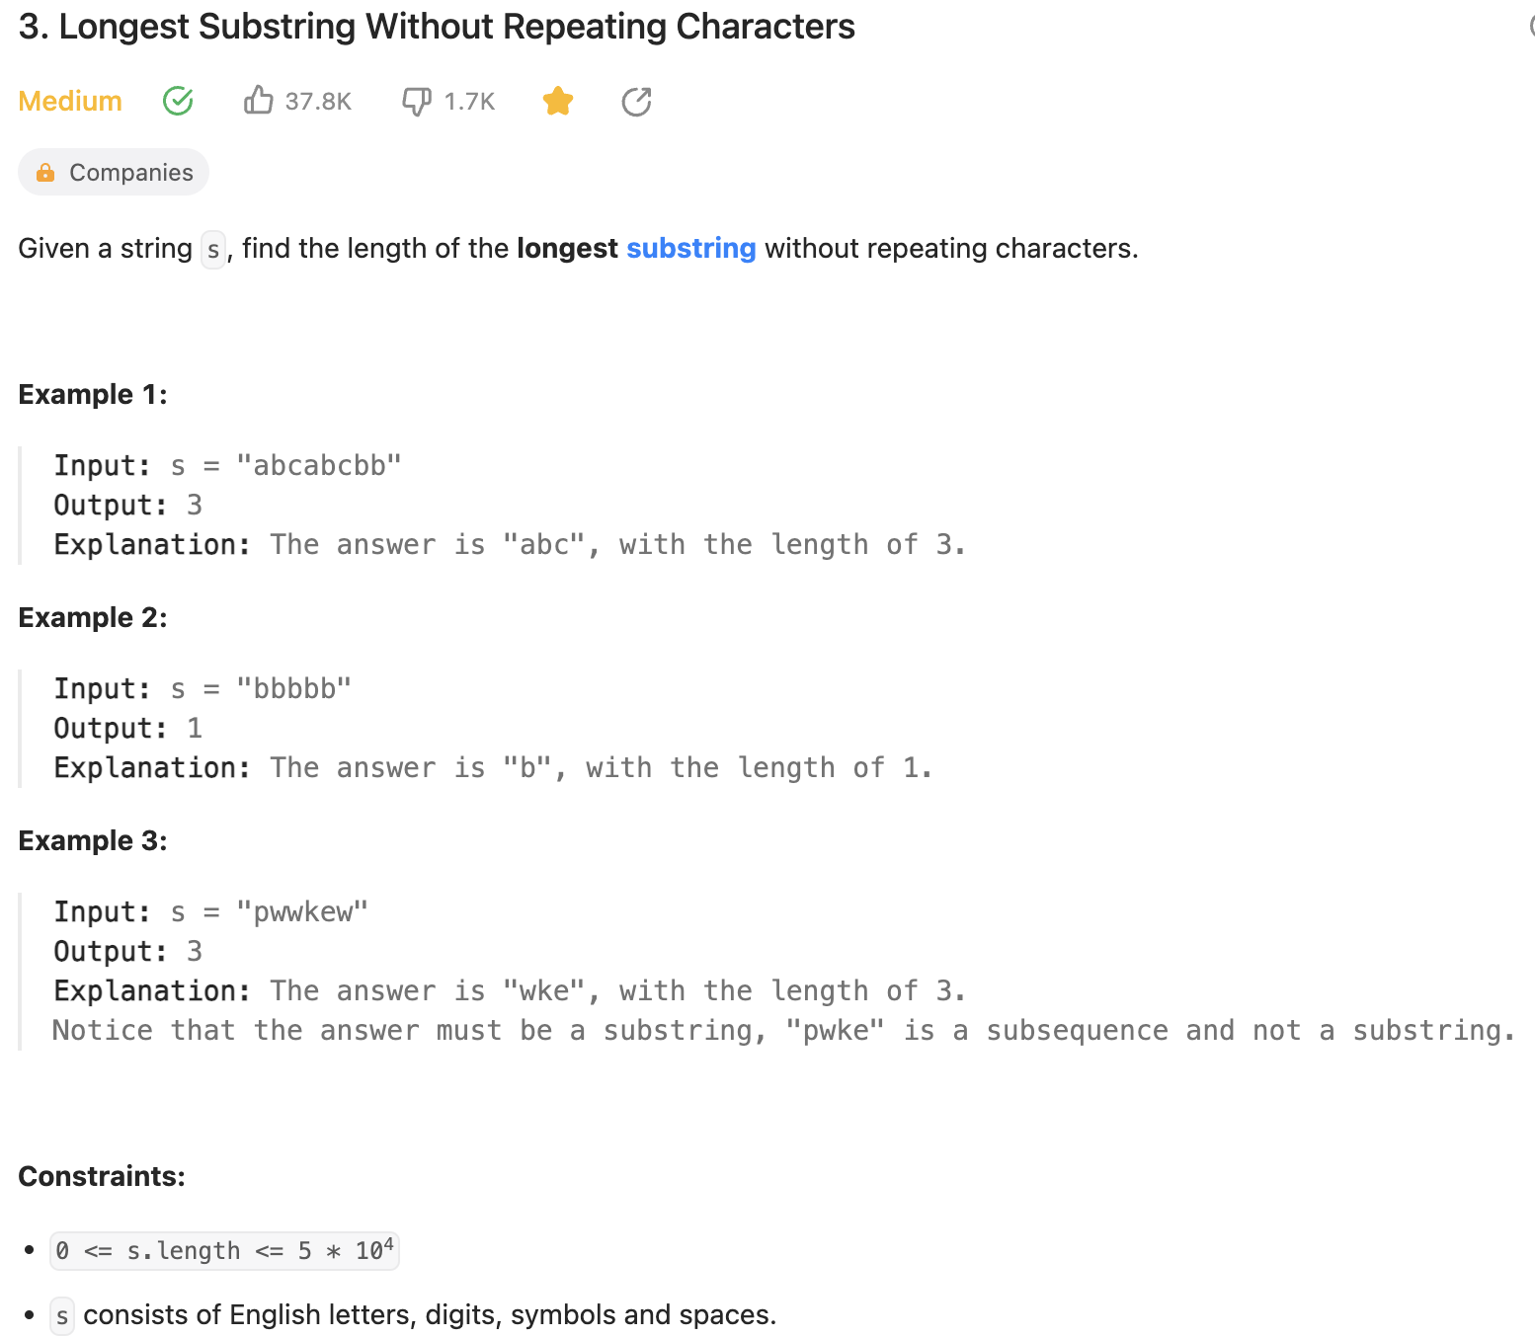

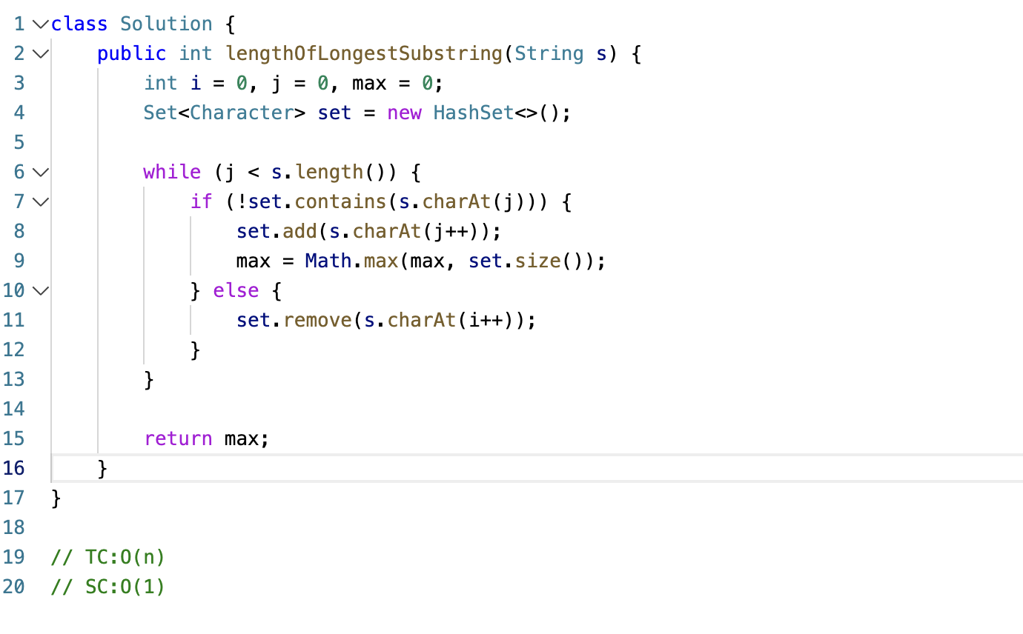

**20. Valid Parentheses**

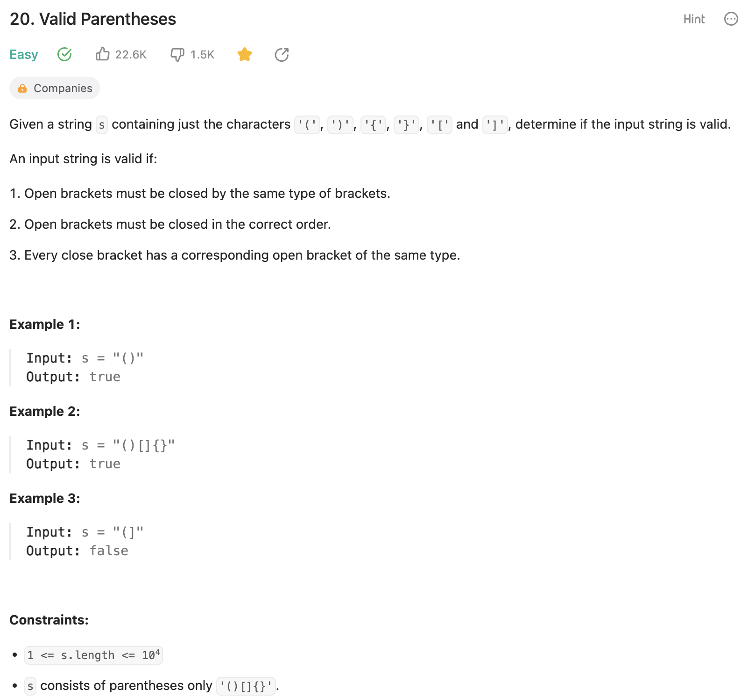

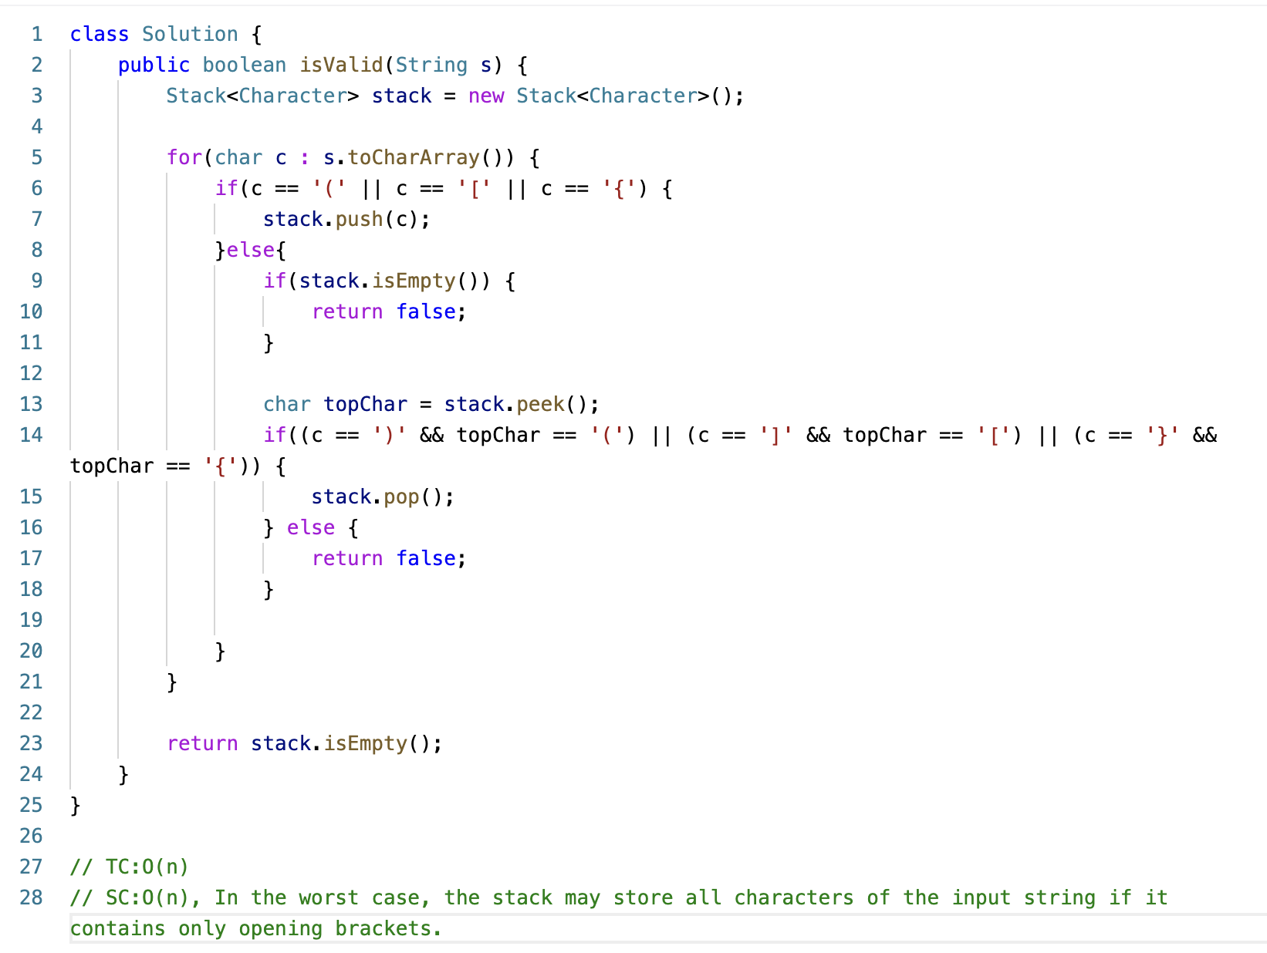

**226. Invert Binary Tree**

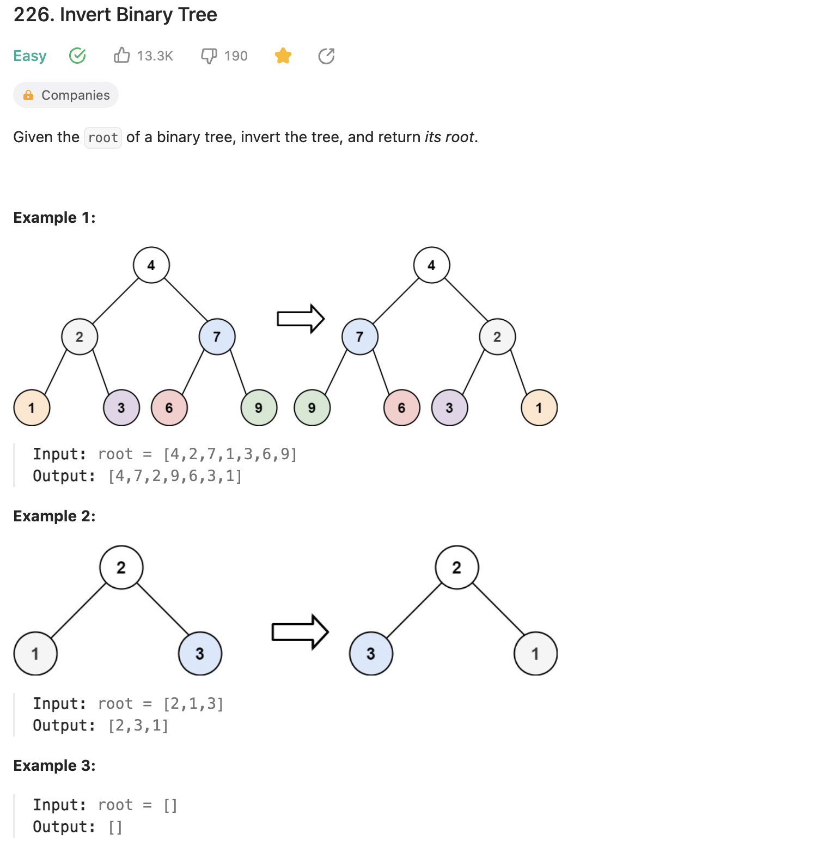

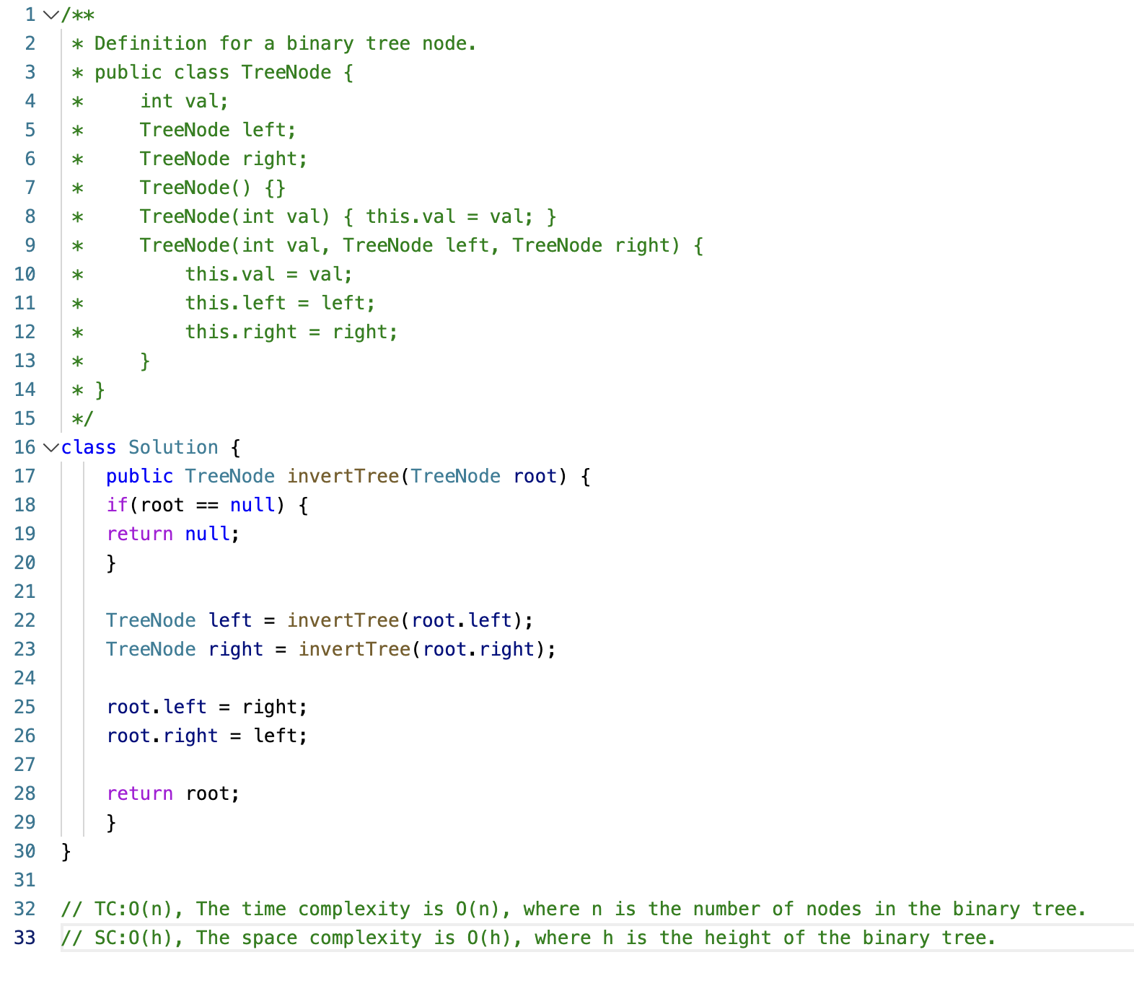

**104. Maximum Depth of Binary Tree**

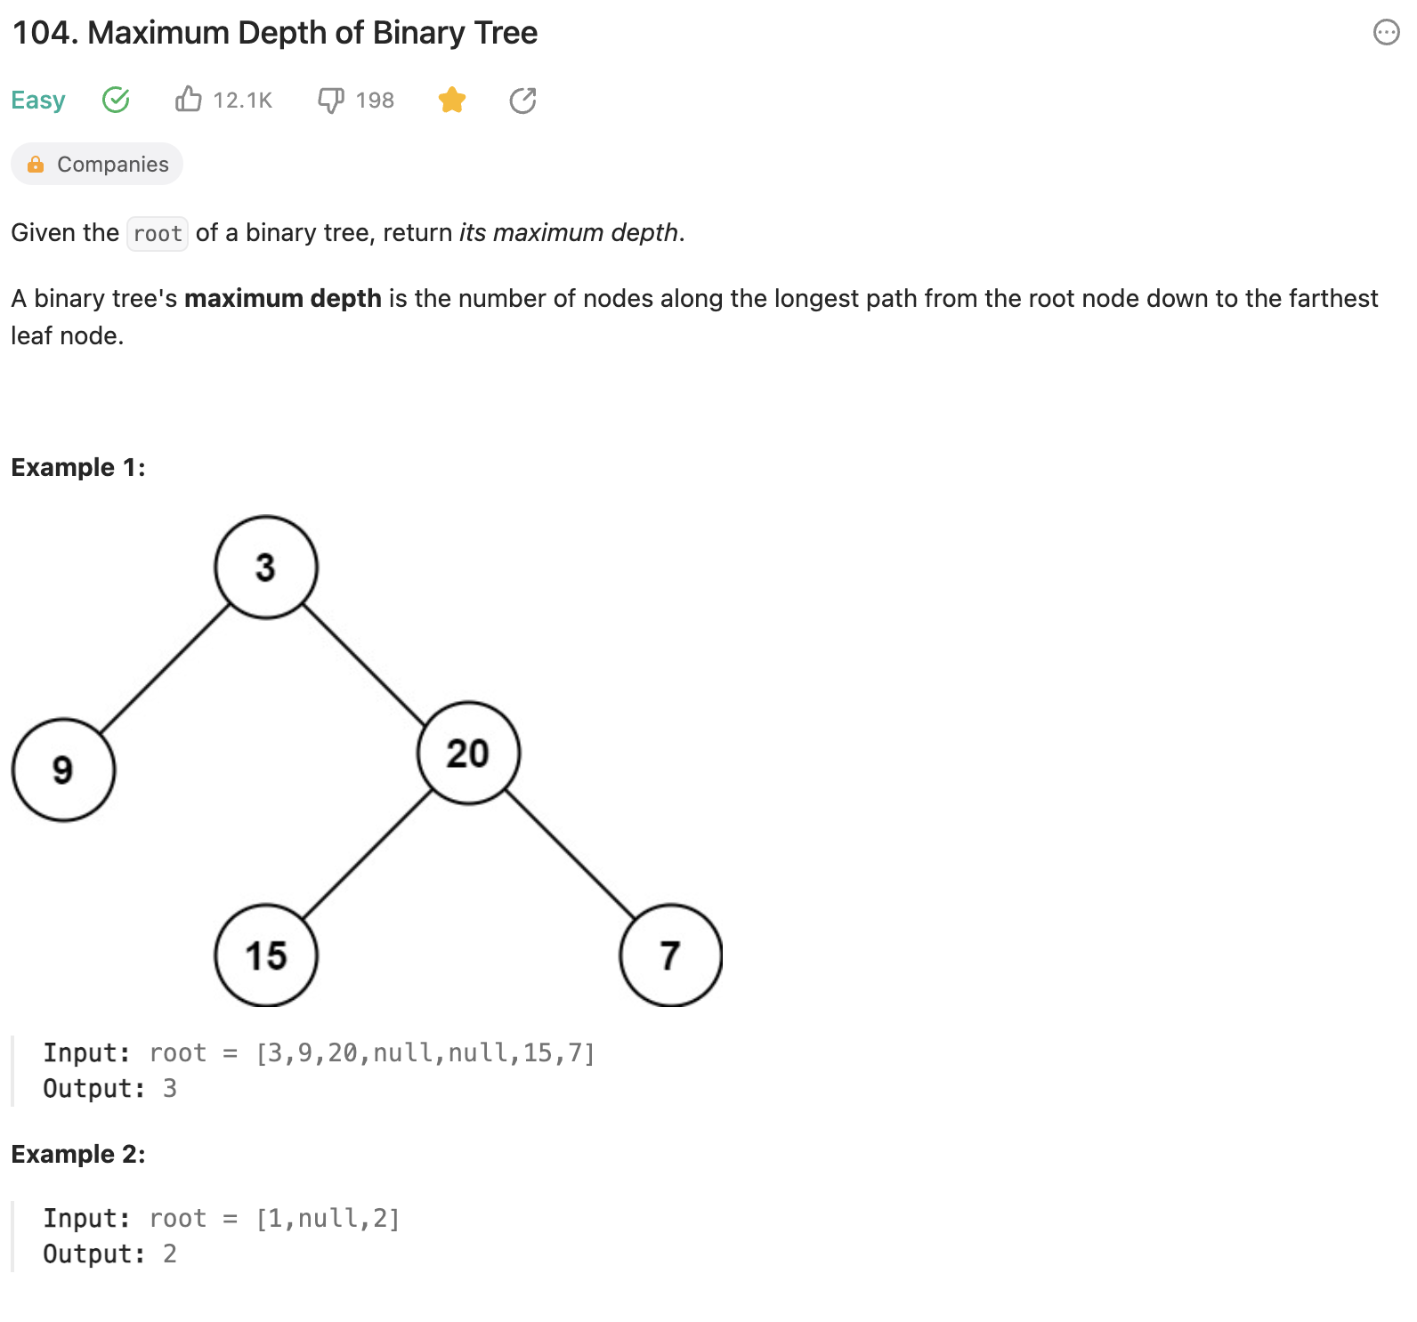

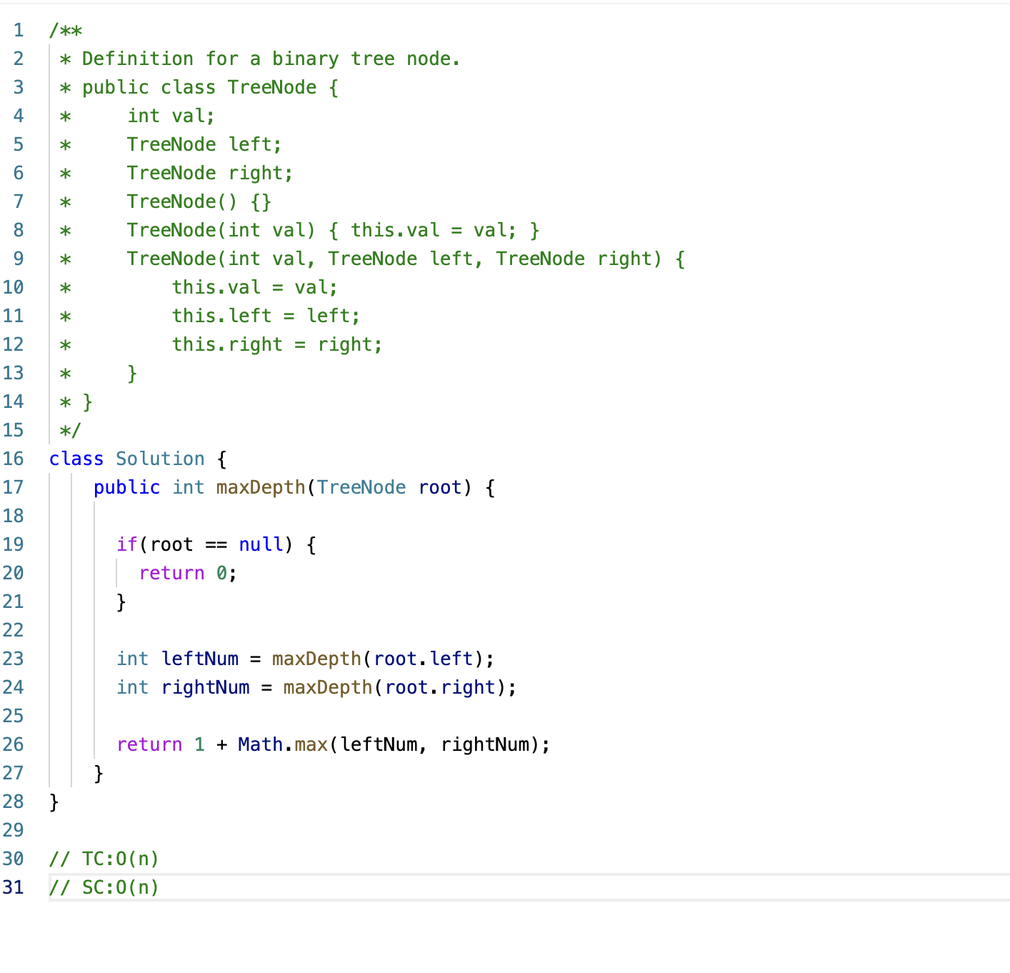

**HackerRank - Plus Minus**

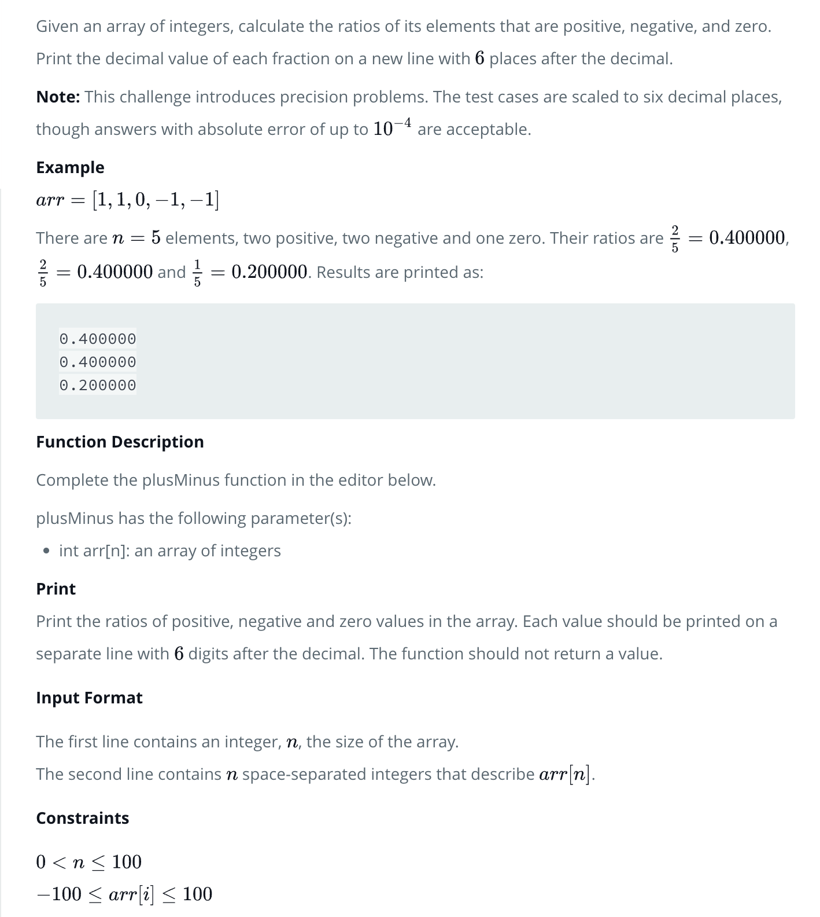

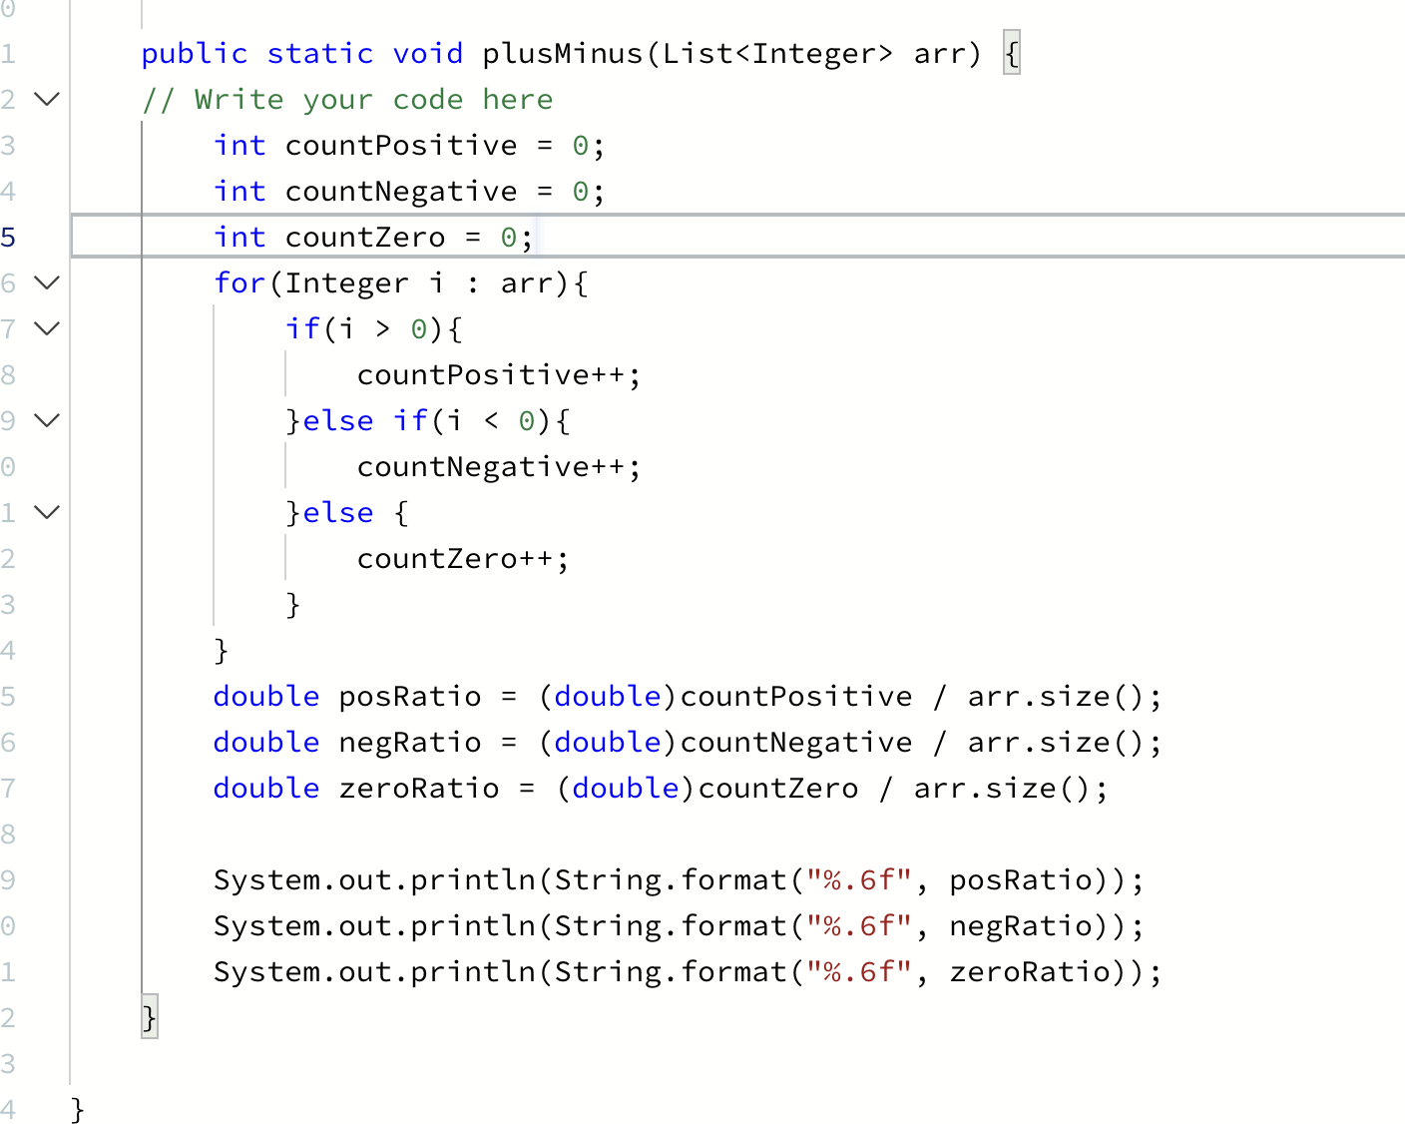

**HackerRank - Mini-Max Sum**

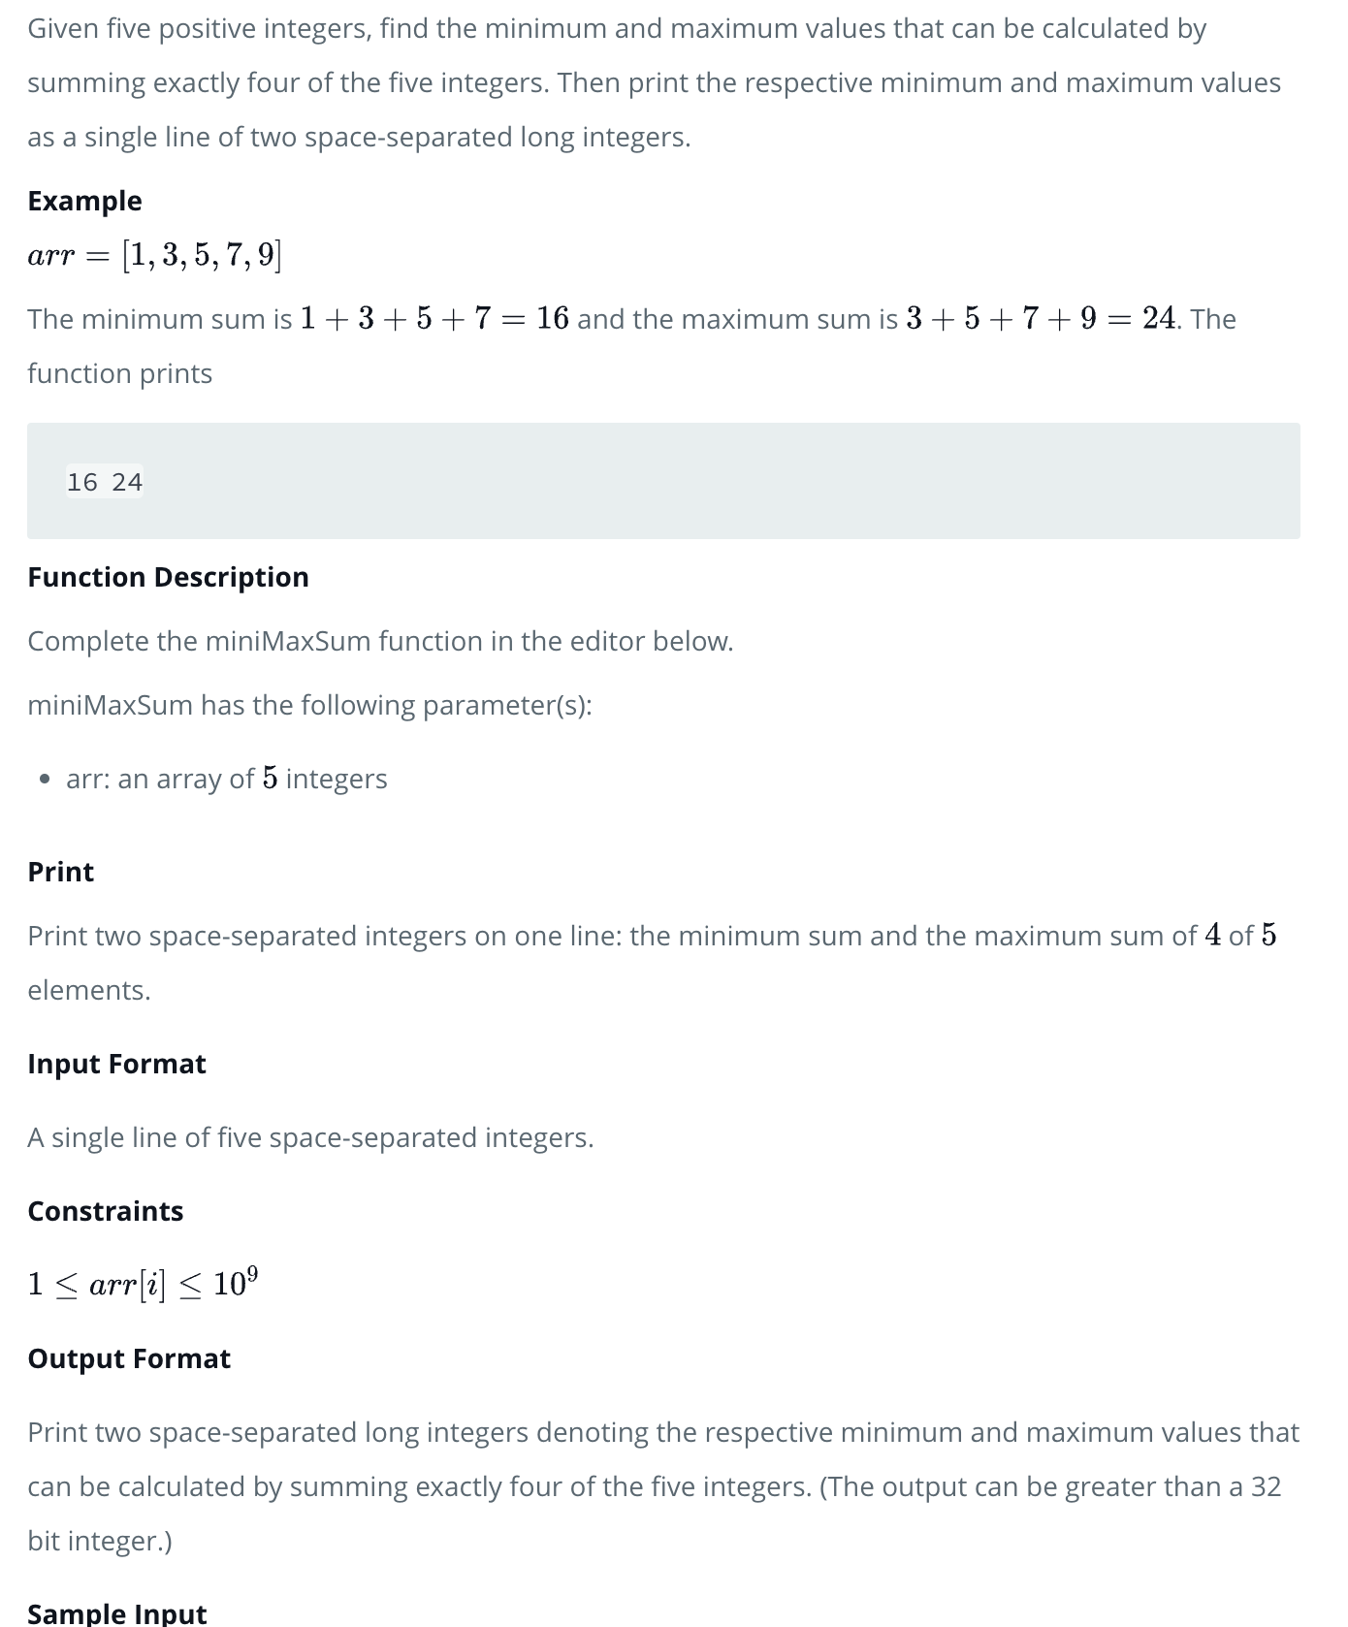

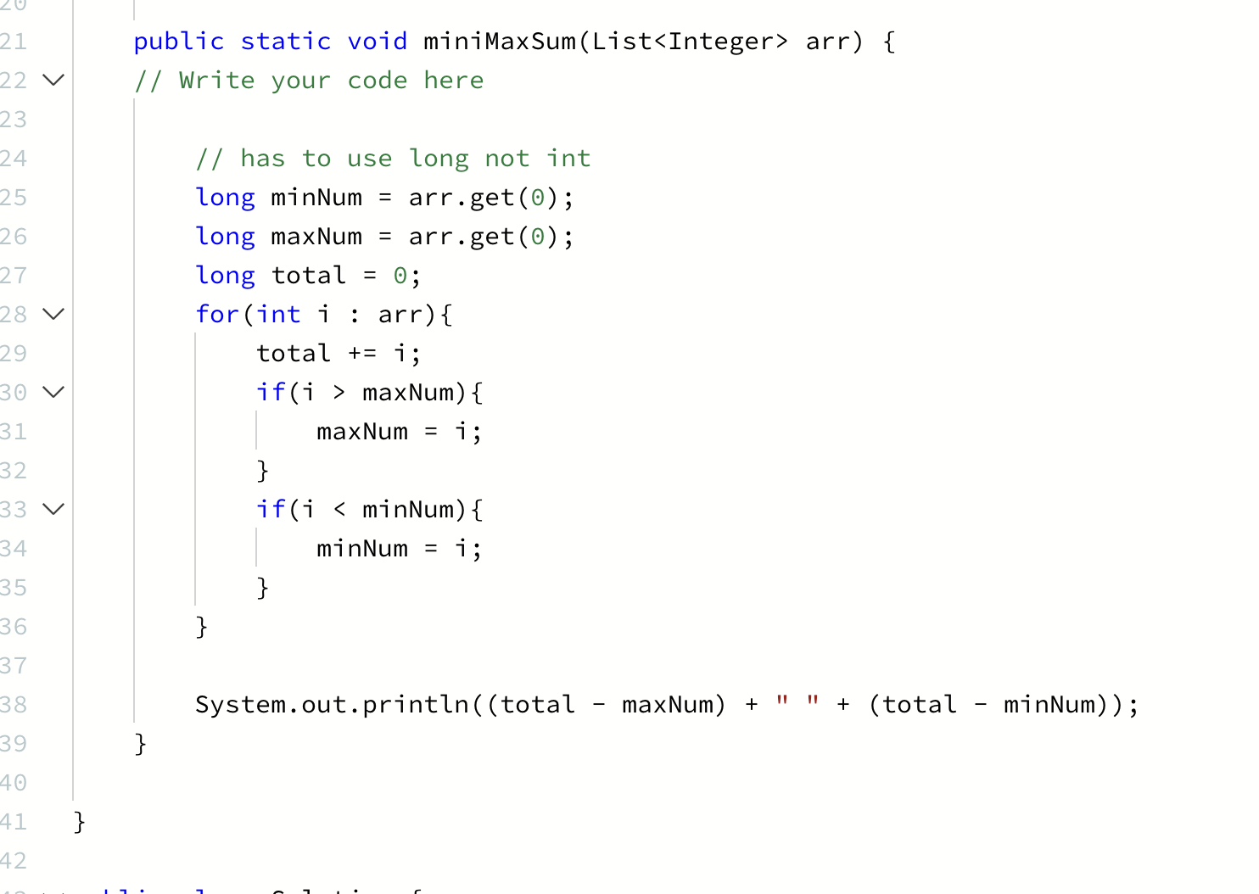

**HackerRank - Time Conversion**

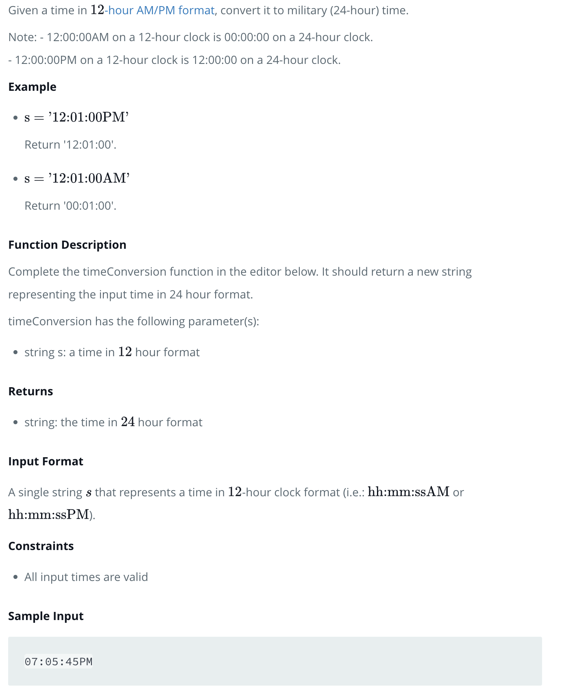

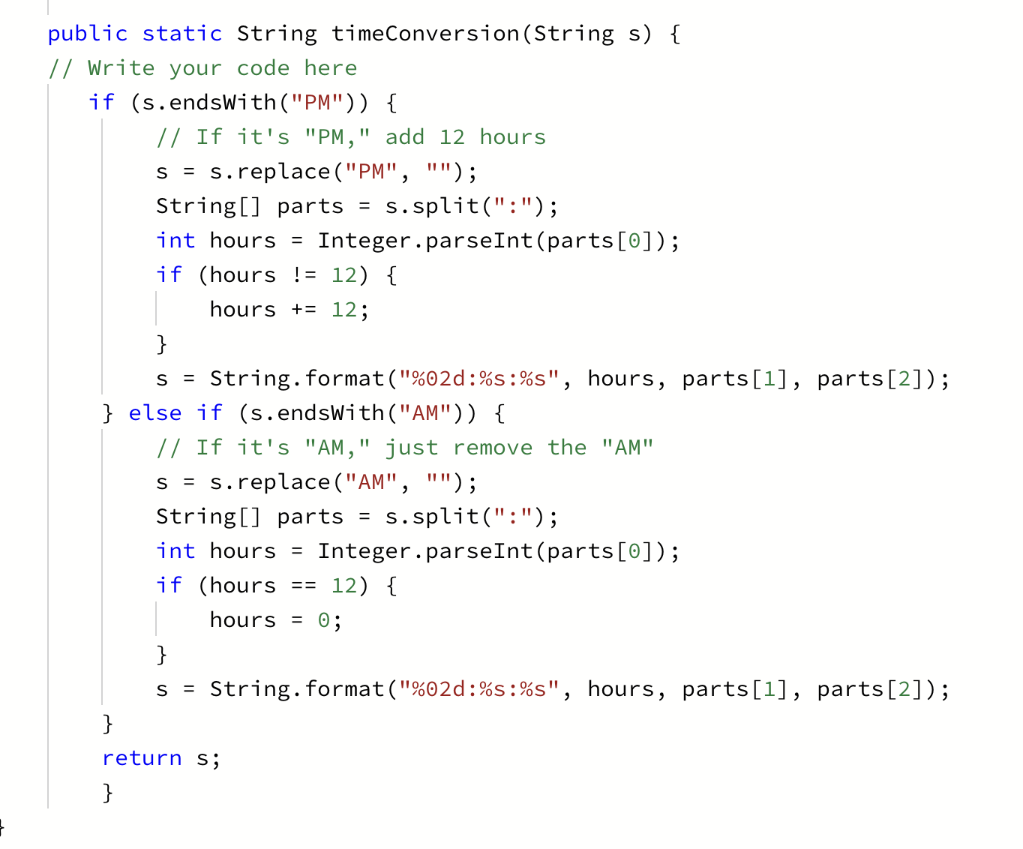

**HackerRank - Find the Median**

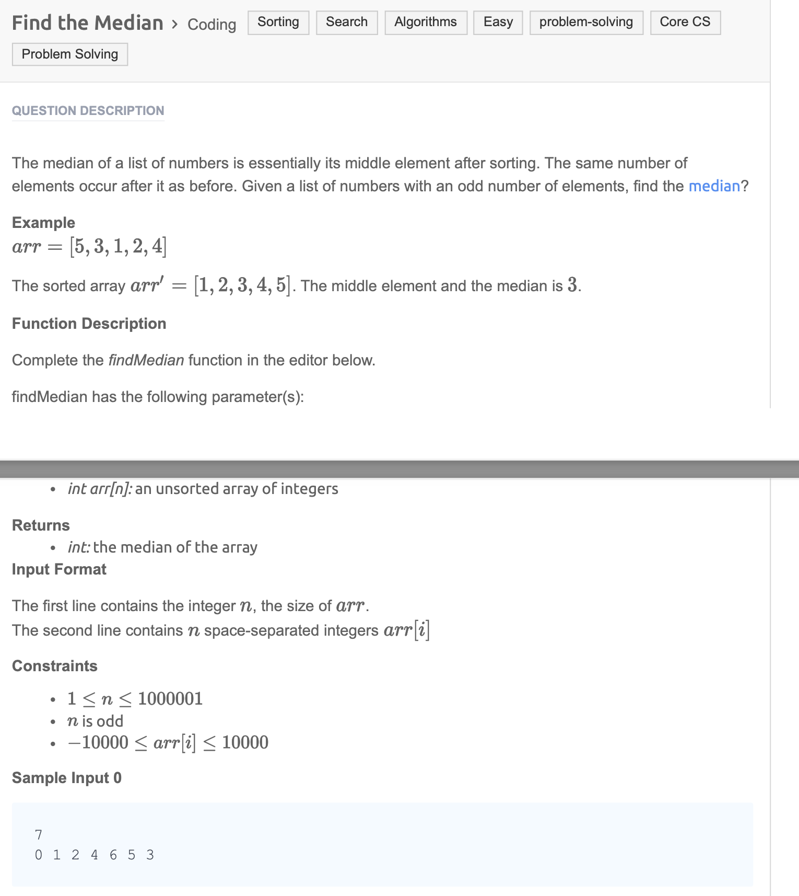

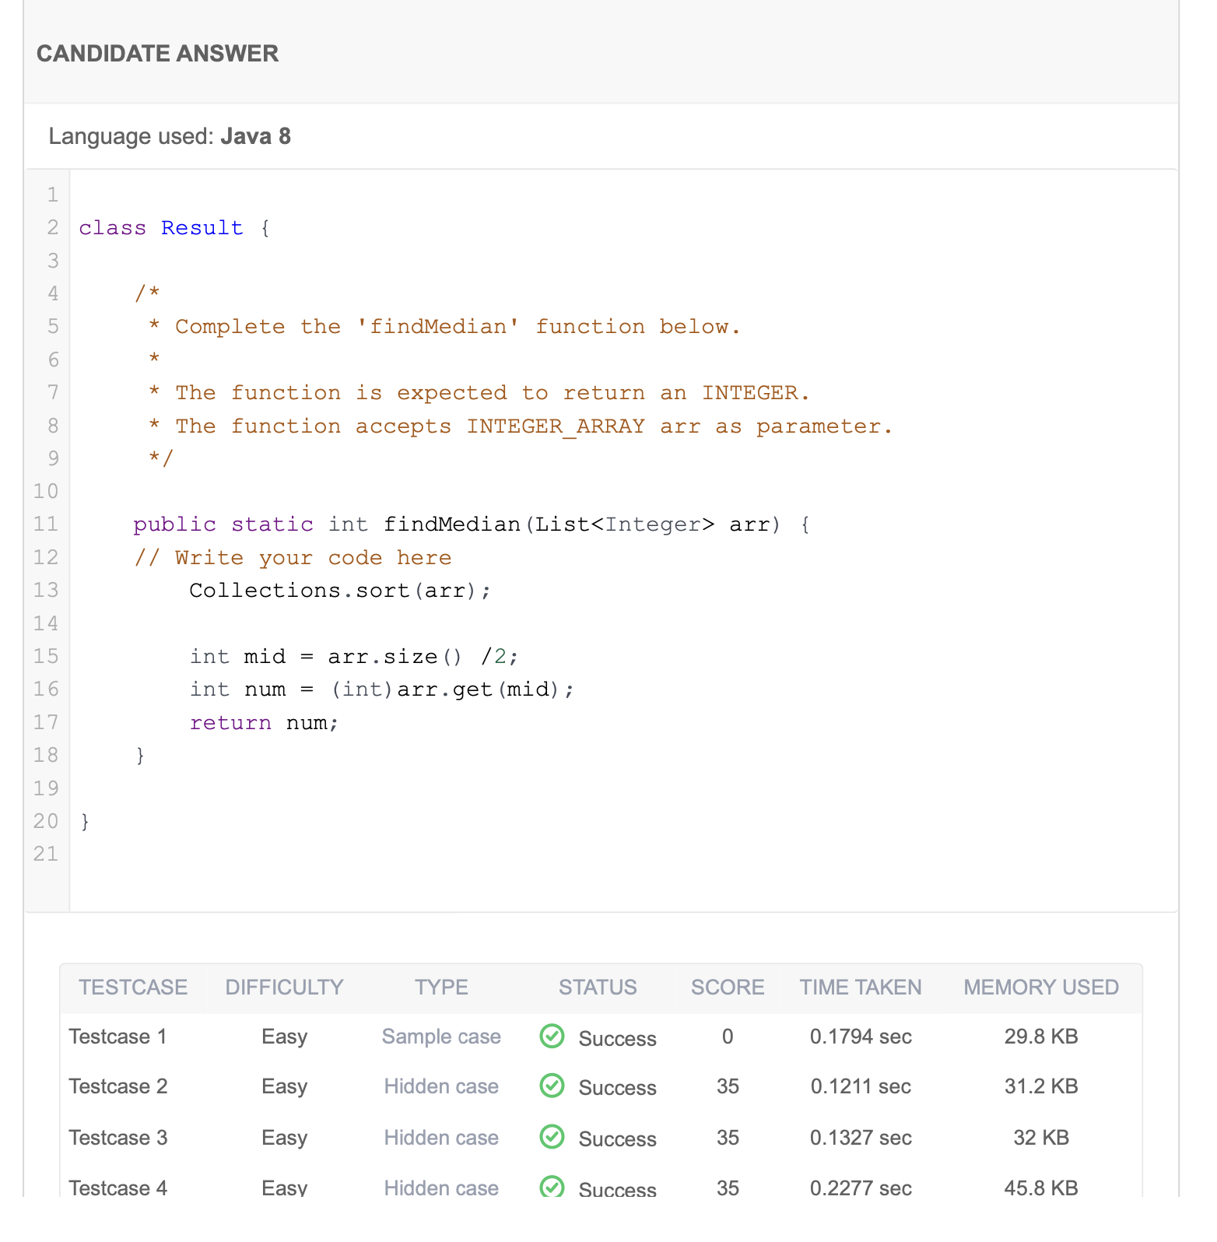

**238. Product of Array Except Self**

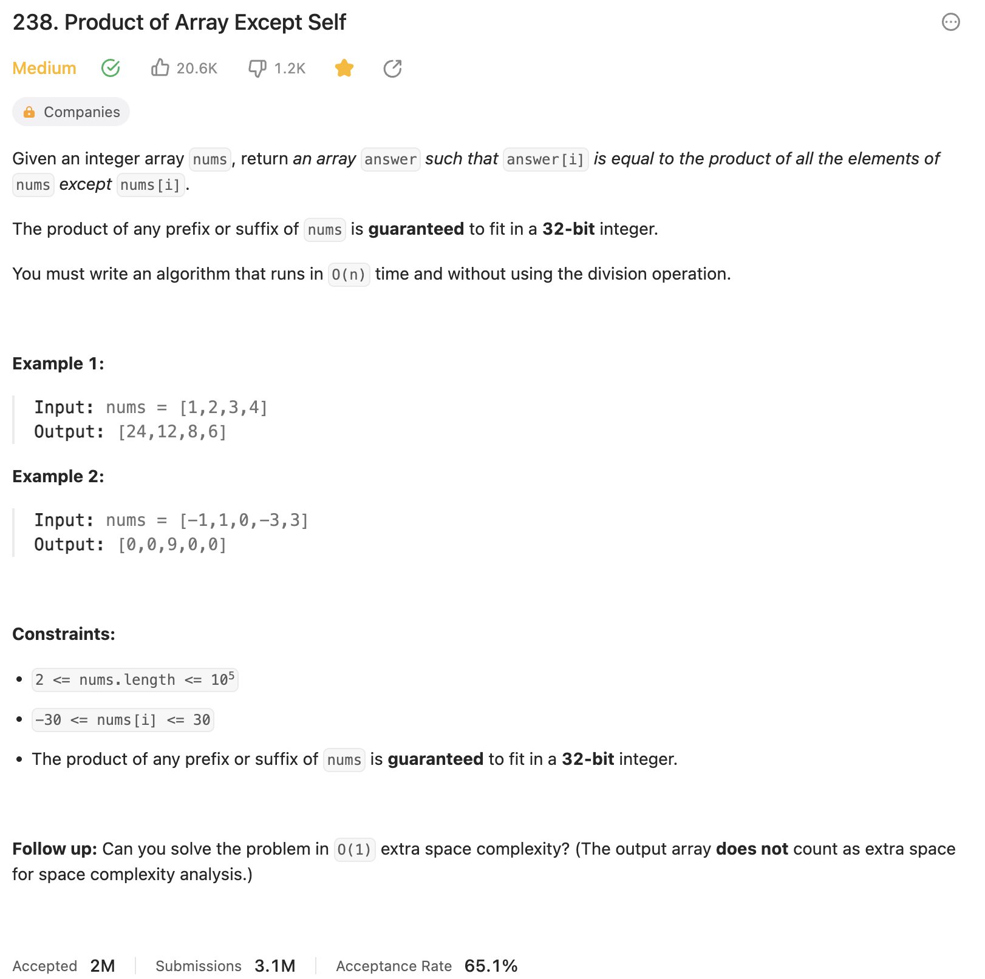

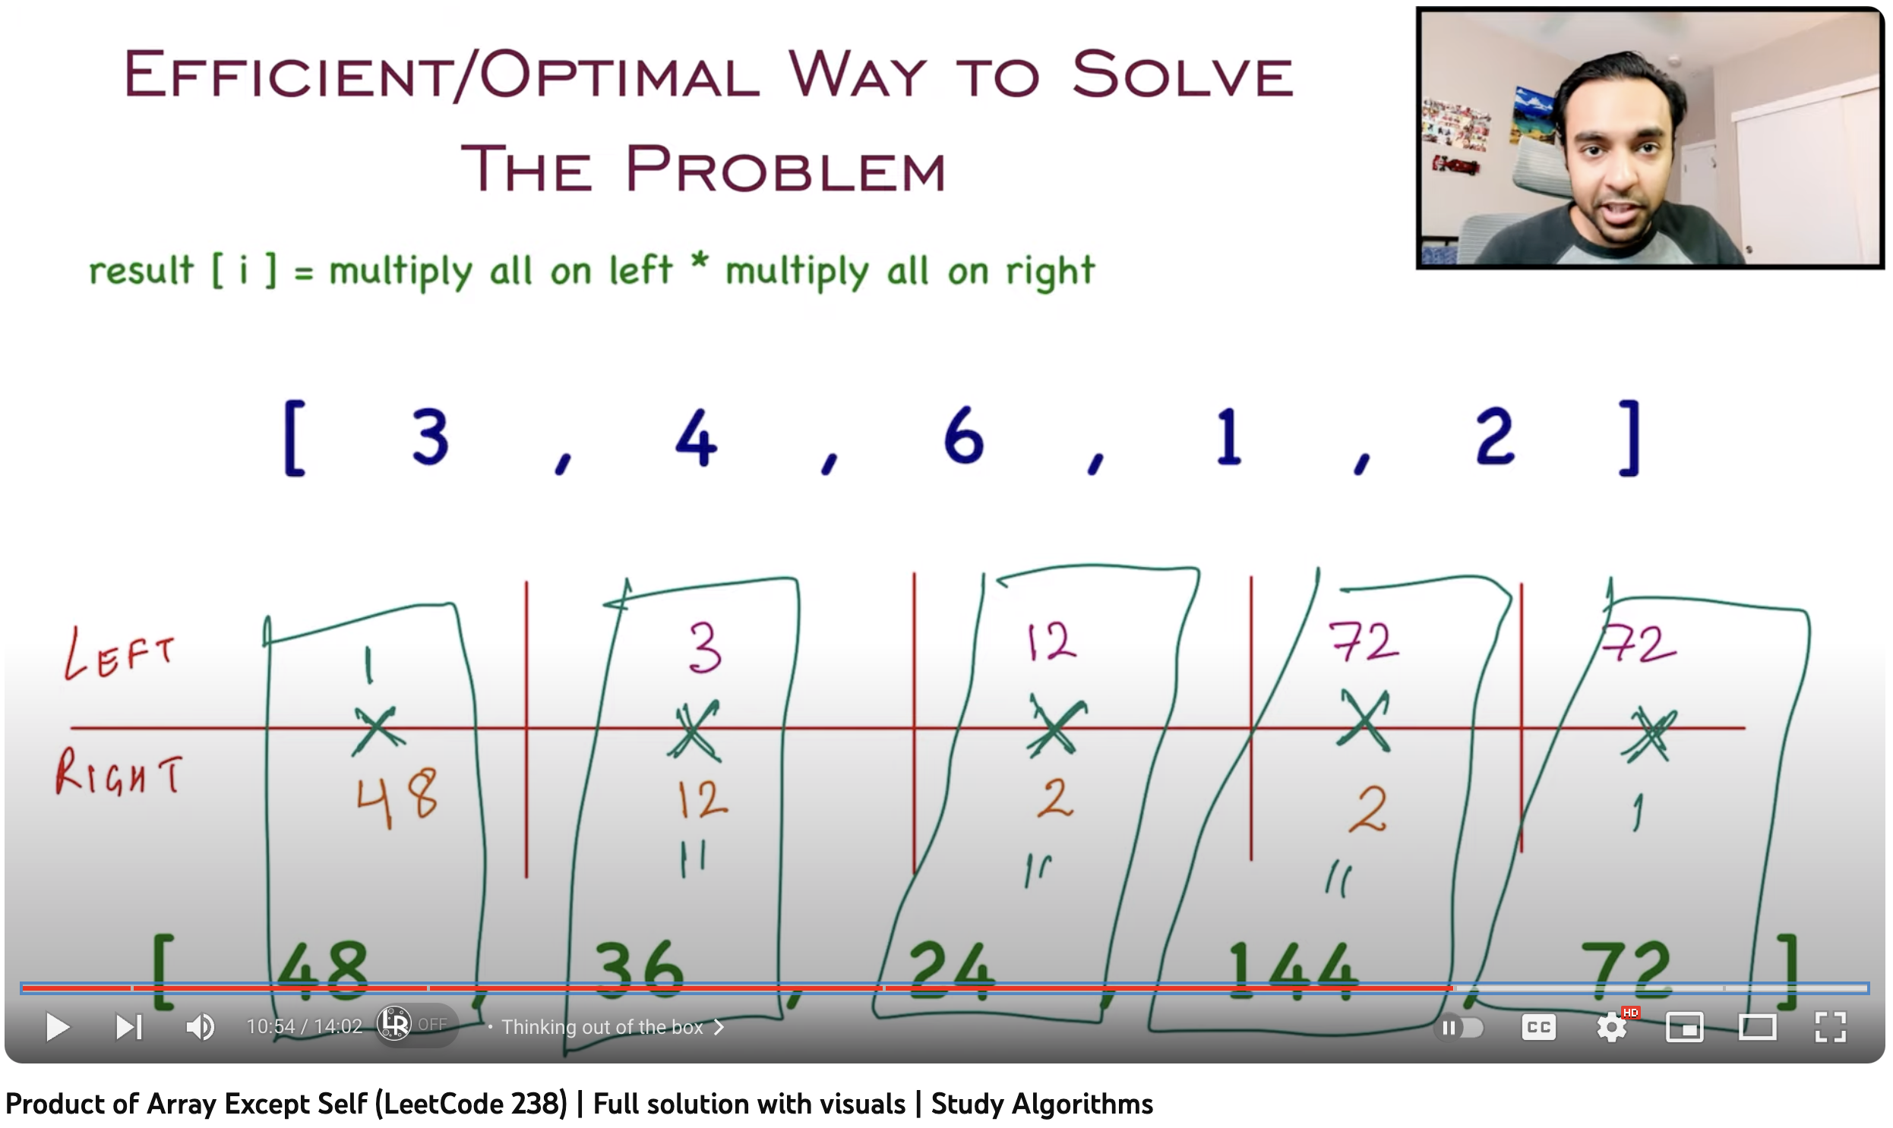

[**https://www.youtube.com/watch?v=G9zKmhybKBM**](https://www.youtube.com/watch?v=G9zKmhybKBM)

